**ReDesign Report**

*BottomLineTelecommunications*

**INF 132 Project Assignment #4**

Monday 6:00 P.M Discussion - Group 7:

Alonso De La Torre Vega

Matthew Morales

Phillip Nguyen

Jason Hing Lun Tam

Juwan Michael De Jesus

Table of Contents

**Executive Summary** **3**

**Prioritized Design Targets** **4**

Big Targets 4

Search Bar: 4

Product Visibility, Discovery and Listings: 4

Small Targets 5

Product Filtering: 5

Product Check Out: 6

Contact Information & Customer Support 7

**High Fidelity Mockups & Design Documentation** **8**

Customer Support and Contact Information 8

Design Documentation for Customer Support/Contact Information 10

Product Discovery, Visibility, and Listings 12

Design Documentation for Product Discovery, Visibility, and Listings 17

Product Filtering 19

Design Documentation for Product Filtering 23

Product Check Out 25

Design Documentation for Product Check Out 29

Search Bar 31

Design Documentation for Search Bar 37

**Appendix** **38**

Problem Space: 38

Screenshots: Search Bar Query and Results 38

Screenshots: Contact Information & Customer Support 40

Screenshots: Product Discovery, Visibility, and Listings 42

Screenshots: Product Filtering 45

Screenshots: Product Check Out 46

Consolidated Designs: 48

Customer Service/Contact Information 48

Search Bar 49

Product Visibility/Product Listings

Product Discovery 50

Product Check Out 52

Product Filtering 55

Team Sketches: 56

Matthew’s Sketches 56

Alonso’s Sketches 56

Phillip’s Sketches 56

Juwan’s Sketches 56

Jason’s Sketches 57

# **Executive Summary**

**Goal**:The goal of this assignment was to perform a redesign of the website shopBLT.com based off of the previous assignments where we gathered real data and performed usability tasks to create as accurate of a conclusion as possible.

**Methods**: The two main methods used to create these new redesigns was through **sketching** and creating **high fidelity mockups**. The first step was coming together as a group and deciding what the big and small targets of the redesign were. The big targets that were concluded were the search bar and product visibility, listings, and discovery. The small targets that were included were product filtering, checkout, and customer support. After selecting these targets then our group was able to sketch about three sketches for each target then each person was assigned at least one high fidelity mockup to work on.

**Deliverable**: Below is the final results of all of the groups discussion and details of everything that had to do with the redesign. Most of the fixes were not too complex within themselves since the biggest problems with most of them was either the placement or the complexity of the way information was portrayed. Aside from the search bar, the four other targets that were decided upon just needed to be simplified and made more user friendly. By using the information from the cognitive walkthrough from the last assignment, it was concluded that the site functions as intended as long as it is executed in a very specific way that is not intuitive to the users. Since this is the case most of the redesigns just required some rearranging and better placement to make it more intuitive for the users. In regards to the search bar the underlying logic was the biggest problem. However, the fix was not extremely difficult since the main thing to do is to change the logic to be a more modern search engine rather than just a binary method where either a keyword exists or doesn’t exist.

# **Prioritized Design Targets**

## Big Targets

### Search Bar:

* Description of Intended Change
  + The current state of the system possesses a feature that allows users to query the site for specific products. The search bar component is outdated and uses boolean retrieval practices in its algorithm. The visibility of this tool is sufficient, however the usability is lacking. The algorithm is based on keywords and cross-checks the query with product names in the inventory index. The feature depends on keyword existence in the product title and will sometimes produce false positives if the keyword is not exact. We intend to change the functionality of the search bar to promote friendly searching; improving usability and error prevention by implementing new logic to provide query suggestions and interpret misspelled queries.
* Source Justification
  + *Usability Tests:* Data from our usability tests shows that queries that do not match specific keywords in product names and titles will produce false negatives stating falsely that a product was not found.
  + *User Surveys:* Data regarding the search bar showed that it was the most frequently used feature to discover and navigate for products.

### Product Visibility, Discovery and Listings:

* Description of Intended Change
  + Three main aspects of the website can be consolidated under this category. The aspects we intend to change all relate to the overall display of information. The generated product listing at the moment displays a dense table of information and lacks images - an important aspect of product discovery. Products listed on the front page of the website are independent of the user and are not categorized in any particular way. Given the products listings (whether navigated to via the search bar or categories) is displayed in a text-based table, the user cannot quickly discern valuable product information. The homepage also does not offer any products that are relevant to the user. These two factors cripple the site’s ability to offer the user an opportunity for product discovery. Users that do not have high domain knowledge must spend an unnecessary amount of wading through product listings and backtracking to find the appropriate product. We aim to provide greater product visibility by providing pictures and make product discovery easier for the user by redesigning product listings visualization. These changes should work toward expanding the user base to be more inclusive to parties that have less domain knowledge.
* Source Justification
  + *Usability Tests:* Data from the usability tests asserts that participants had trouble reading the information presented in product listings table. Participants were unable to determine if a product found matched the product outlined in the usability test requirements because there were no pictures, and the tables were reportedly “difficult to read”.
  + *Cognitive Walkthroughs:* After gathering data from the usability tests our team investigated the product discovery and visibility aspects of the product listings visualization. We found that some products do have images both in the product listing and the product page, however, finding the option to display the image is difficult. Furthermore, once the image is displayed in product listings we found it was troublesome to try to get rid of the image. Our team also discovered that parsing the information in the tables is rather difficult.

## Small Targets

### Product Filtering:

* Description of Intended Change
  + This feature serves the purpose of reducing and condensing product search results for users. However, where it currently sits on this website is hidden from the user, at the very bottom of the webpage after all the product search results. The user has to scroll all the way down, pass 25 product search results, in order to reach the filter table. Along with that, the options given to reduce the search results are unorthodox and different than what users are accustomed to. For example, the given options for pricing are “Anything”, “Equal or Less Than”, “Exactly”, and “Equal or More Than”, which are all pricing options that modern shopping websites don’t occupy. We’re going to take inspiration from competitive websites and follow the same idea of utilizing the left side of the webpage, to make a customary ‘Advanced Search’ filter table. The user will see what categories the product search results can fall under and will be able to have the option of selecting a specific manufacturer from a list of partnered manufacturing companies and inputting a price range to narrow the results.
* Source Justification
  + *Usability Tests:* Data from our usability tests suggests that feature discovery was difficult for users; they had a hard time finding this tool and didn’t know it existed on the website, until were guided to it.
  + *Cognitive Walkthrough:* Data from our cognitive walkthrough suggests that the functionality of the filtering feature doesn’t actually work; when a user specifies a certain option along with a price range, the product search results remain the same rather than condensing and becoming more accurate.

### Product Check Out:

* Description of Intended Change
  + The product check out is poorly designed. The checkout process asks for the user’s email address in the billing information when it would make more sense to put it in the user information section. The process also includes two separate options to navigate forward in the checkout process, proceed using a secure checkout, or an insecure checkout method. This additional step is superfluous in the process, as each option navigates the user to the same checkout page located within the same server. This shows that the developer of the site changed the checkout process but did not revisit this step to produce a more streamlined and clear procedure. The process asks the user’s daytime and evening phone. The goal of the intended change would to consolidate the two checkout options into one option that would work for all consumers; it would save an extra click for the customers. It would also help to take out unnecessary information such as ‘Organization Name’ and the evening phone. We intend to consolidate the information presented in the prerequisite steps of the checkout process, and offer a new method of payment that would provide more variability in payment procedures in an attempt to reach a wider user base.
* Source Justification
  + *Usability Tasks:* Our users commented that copying/pasting information was annoying and that if the form was submitted with an error, it would have to be re-done and that was very time-consuming.
  + *Cognitive Walkthroughs:* Having to pick between two checkout options is time-consuming when the consumer can be automatically directed to one without having to waste time being confused. The customer also has to fill in the same information multiple times (i.e. phone numbers for both the evening and the daytime)

### Contact Information & Customer Support

* Description of Intended Change:
  + Our TA, Hillary, mentioned that website’s tools for customers to receive help are interlaced with many clicks and superfluous information that could come off as less than hospitable. This may give off the vibe that the website may not want to help its customers. Customer service is an important aspect of any business and customers who are afraid to ask for help or are turned away by the terminology may end up going to a competitor with better service. With this in mind, the change that would be best for shopBLT would to have a customer service experience that does not make the customer feel bad for trying to ask questions and is not riddled with information and multi-level navigation to get to the contact information. The information, regardless of how trivial the question may be, should be readily available to the user to promote a hospitable and friendly user experience.
* Source Justification
  + *Expert Analysis:* Our expert analysis on this issue comes from inspiration from other competitive websites, such as: Best Buy, Amazon, NewEgg, and eBay. When analyzing all these websites as a whole, we realized they had a set of norms when it came to their customer support reference page. For starters, they all believe it’s important to separate their customer complaints into different categories - this way customers can identify their issues quickly and easily. Some of the websites go more in depth with their categories, but, for the most part, they all have a similar basis as to what they consider to be typical customer concerns. They relate primarily to the most frequent issues presented by customers that they face. Once they’ve chosen a category, the user is presented with the necessary information and steps needed to solve their problem. The steps are easy to follow and the information is easy to comprehend; the page is not an overload of information. More importantly, the language and tone used by the website to communicate this information to the user is friendly and inviting.

# **High Fidelity Mockups & Design Documentation**

## Customer Support and Contact Information

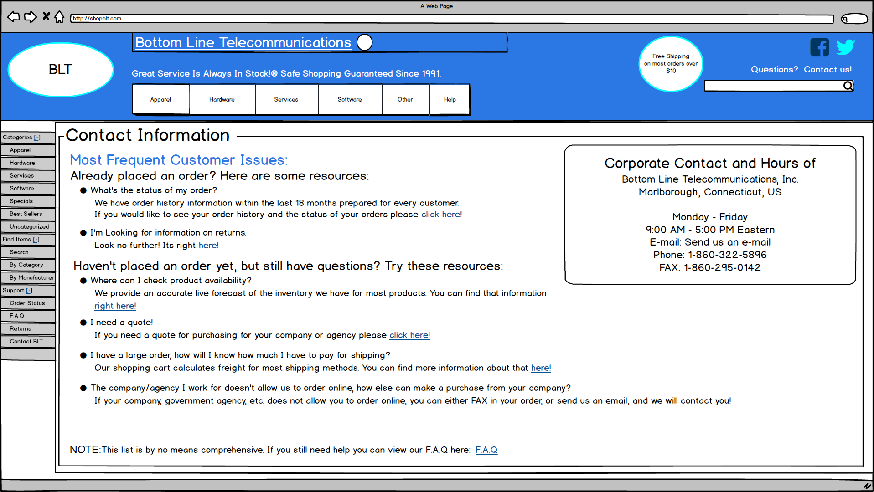

Figure A: High fidelity mockup of the customer support/customer information design target.

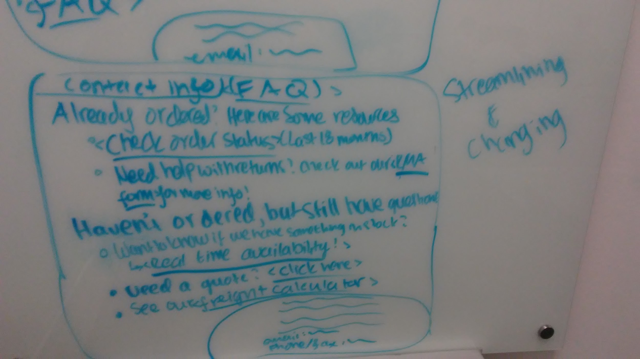

Figure B: Sketch of the categorization of information for the contact information page.

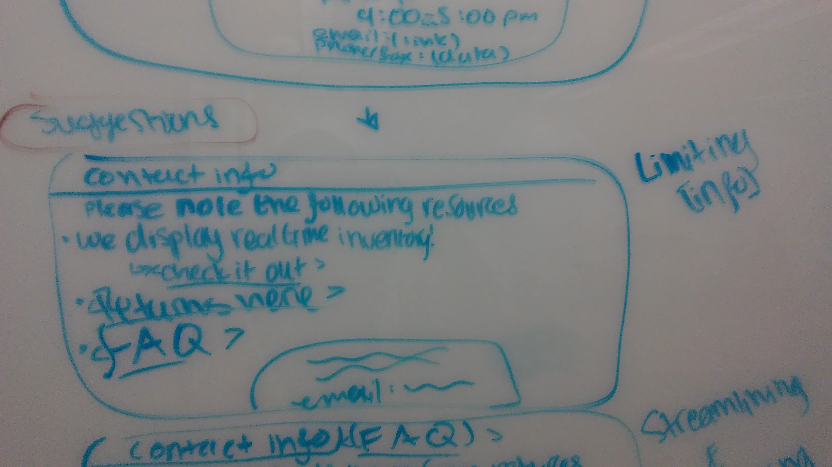

Figure C: Sketch of the minimization of information that inspired the streamlined method of indirect communication with the customer.

## Design Documentation for Customer Support/Contact Information

* **Problem:** The customer support and frequently asked questions pages on Bottom Line Telecommunication’s website has poor customer orientation and indirect customer interaction. As noted in Figure(s) 5 & 6 (see appendix), the information displayed on these pages is both verbose and cumbersome. Customer’s seeking quick access to straightforward information must wade through a plethora of text, minimizing the importance of the customer’s queries and projecting an attitude that is less hospitable. The terminology has been described as “snarky” and “unwelcoming” by parties who have reviewed the site, including our development team and user experience researcher Hillary Abraham. In sum, the site does not offer a more friendly and inviting environment for indirect customer interaction, and openly discourages customers from reaching out via methods that would establish a direct connection between the customer and the company.
* **Evidence:** As noted above, the issue was primarily introduced to us by user experience researcher Hillary Abraham. After she had brought this issue to the attention of our team, we revisited qualitative data we received from our user research and interviews. We have data to support that customers and users alike prefer quick and easy access to information regarding products, ordering, and retailer policies. We also researched and compared the structure and language used by competitors in their customer support section, revealing practices that organized the information neatly into small text packages as well as encouragement to reach out to the company with any and all inquiries. The contrast between (customer expectations and competitor practices) and shopBLT’s execution of approaching customer service was staggering.
* **Process:** The range of our designs reached from changing only the terminology and wording, to removing it all together. We also considered reorganizing the presentation of information, and where the actual contact information would be placed. Sketches were done to communicate the categorization and groupings of the text presented to customers as well. While these methods produced important design artifacts, our main focus was creating a more welcoming environment to the user, eliminating the discouraging sense presented on the site now. We consolidated our design ideas by iterating through all of the sketches and cherry-picking the best features that fell in-line with our expert opinion and key points found from user research. We chose this final design because it uses collective terminology (words like “we” and “us”) and took an approach to delivering information that streamlines the information to the customer and is oriented around the customer.
* **Results:** Our designs aimed for more friendly indirect interaction with the user. We also utilized collective terminology by using words like “we” and “us” and took an approach to delivering information that streamlines the information acquisition process and is customer oriented. We also focused our efforts in establishing good use of design real estate. The goal was to provide friendly user interaction with quick access to information while maximizing potential use of screen space (minimizing white space). Figures B and C show the ideas for organization of information by categorizing them into relevant sections: “already ordered” and “have yet to order”. We only provided a high fidelity redesign for the “Contact Us” page and decided against redesigning the F.A.Q page as well; given that the F.A.Q. page possessed an inordinate amount of text content. Rather we sought to provide a model for customer support and indirect customer interaction that can be applied to other areas of the site. The redesign presents the information in a more friendly and encouraging way. We changed the terminology and structure of the wording presented on the page to promote a more hospitable and welcoming environment. We also moved the contact information from the bottom of the page where it was (buried underneath text) so that it is readily available to the user, indicating that direct communication is welcome and encouraged. The categorization follows that presented on the website now to retain familiarity with existing users. The disclaimer prompting users to review all text based information before reaching out to the company has been removed as it was seen as “snarky” and “discouraging” by our team (expert opinion).

## Product Discovery, Visibility, and Listings

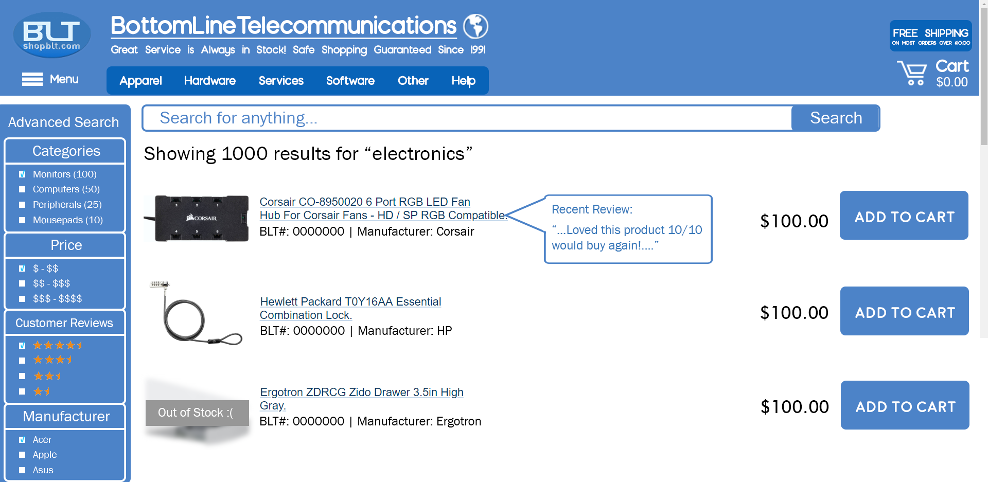

Figure D: High fidelity mockup of the **product listings** and corresponding images to improve **product visibility**.

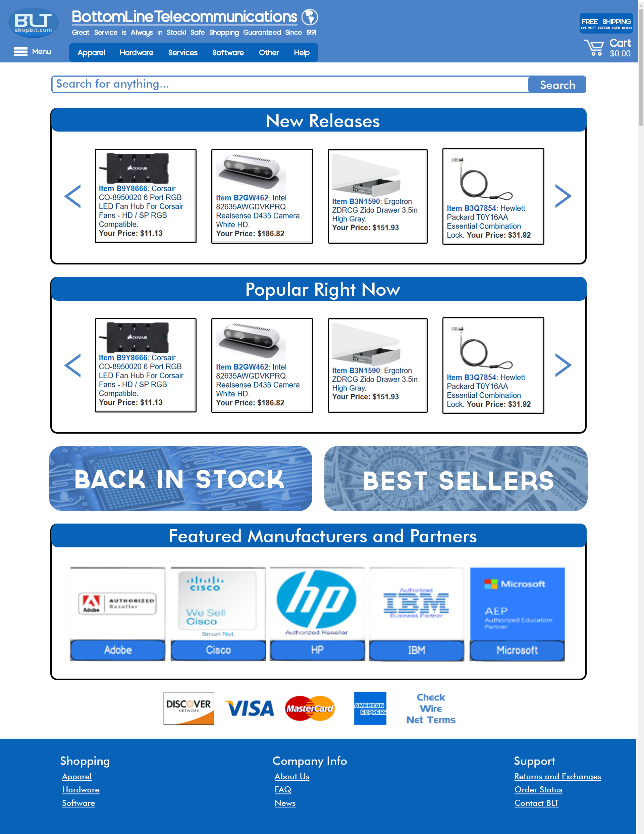

Figure E: High fidelity mockup of the homepage. Homepage redesign is targeted towards improving **product discovery** and **product visibility**. (Figure shows entirety of page, actual implementation will involve scrolling).

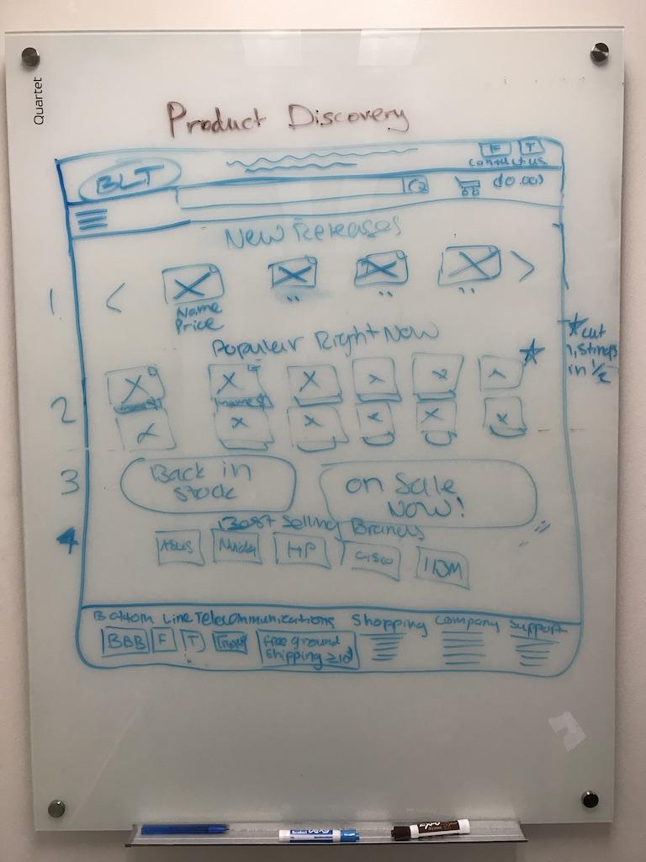Figure F: Consolidated sketch to demonstrate a redesign promoting **product discovery**. The homepage now prioritizes real estate for product advertisement, displaying most recent products in shopBLT’s inventory. Irrelevant information has been moved to the bottom of the page. Redesign also focuses on *showing* trustworthiness, rather than stating the site is trusted. Logical artifacts for stating trustworthiness are still present, but are now on the bottom of the page.

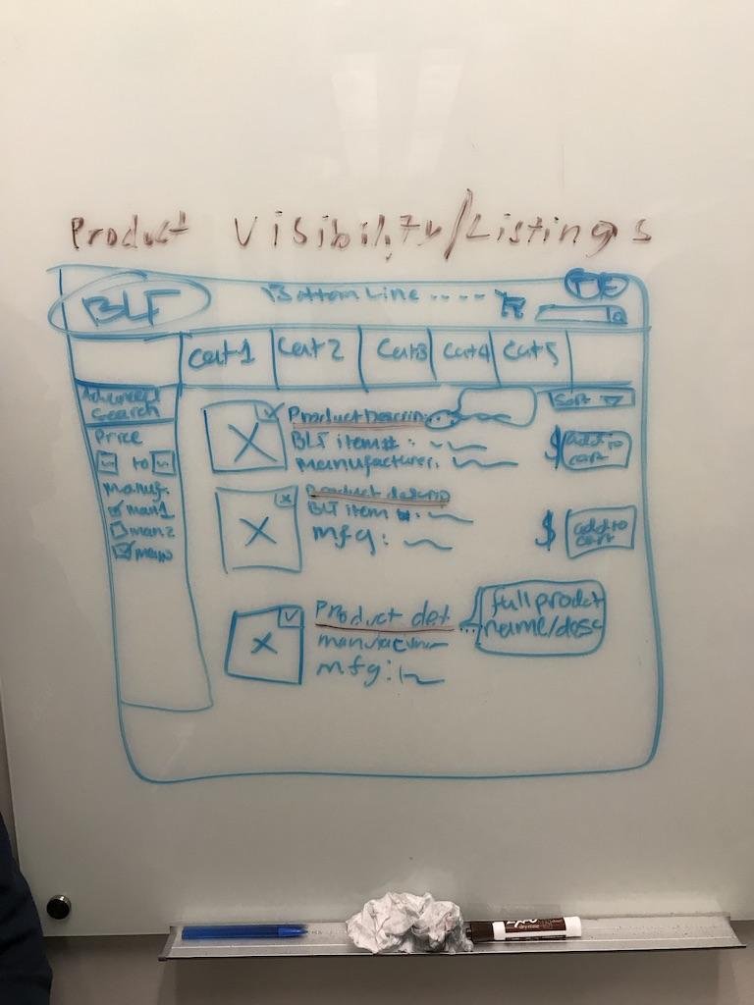Figure G: Consolidated sketch for product listings. Showing a more readable format for products, while maintaining the same type of information displayed. Product images have also been added to provide greater product visibility.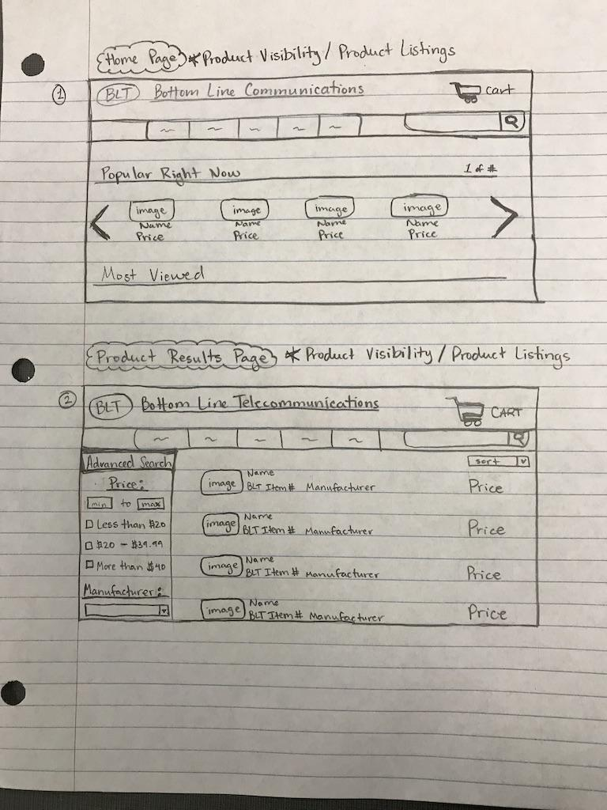Figure H: (Sketch by Alonso De La Torre). Served as the primary inspiration for the redesign of the above design target.

## Design Documentation for Product Discovery, Visibility, and Listings

* **Problem:** The current state of the design for product visibility, discovery, and listings is lacking. User research conducted by our team shows that consumers value and depend on certain kinds of information to make an informed decision before purchasing an electronic item online. Information such as: price, product details, retailer reputation, and product images are important to the user. Among those, our research shows that within our participant population, product visibility (images), price, and reputation are the most important. The current design does not support increased product visibility in a user friendly fashion as shown in Figure 7 (see appendix). Product information prioritization is not optimized with the current state of the product listings page. Some information is irrelevant and can be placed directly on the product page, rather than in product listings. We decided to redo the homepage as well, given it is the primary landing page for the company. The homepage of competitors present a number of interactive listings and options that entice the user or customer to become engaged in the site and allows for greater chances that a customer finds something they may want or need. The site introduces itself to the user by declaring that it is indeed a trusted site and has good standing within an official review. We wanted to present a more engaging atmosphere to the user and also show the site can be trusted, rather than stating it is.
* **Evidence:** When conducting our user research, we discovered that many of our research participants value the ability to have a visual representation of the product, as it allows the customer to get a better sense of the product they are going to buy (especially when shopping for electronics). Our user research showed that ~50% of our research participants prefer in-store shopping to shopping online because of the ease of access to product information (customer service) and the customer can see and feel the product before they buy it. Qualitative data from our interviews suggest the same thing, as ~60% of our participants stated they sometimes shop in stores because of greater product visibility and access to information. Additionally, from those participants who did answer that they shop online for electronics, we also see ~75% of individuals using external online resources (such as Google, and YouTube). When asked why we received responses stating that these external resources helped the participant paint a better picture of the product, how it’s used, and whether it will fulfill the needs of the customer. Furthermore, when conducting our usability tests we recorded several comments regarding the availability of product images. A quote from one of our participants from the usability test, commented on the product listings and product visibility “It’s confusing because I don’t even know how its sorted, it looks kind of random, because you have the product information but it’s the fourth column in the table and there are no pictures.”
* **Process:** The sketches for this redesign ranged from simple changes like adding product images and condensing information to performing a complete overhaul of the product listings and the organization of the homepage (product discovery). After each team member built their sketches individually, we laid out all sketches and presented them for review. We filtered out the sketches that possessed similar problems to the home and product listings page, but kept good suggestions like image placement and which information to preserve. We then chose from three separate designs, the best features to be consolidated into a final design. Figure H shows a sketch done by one of our team members, which heavily inspired the product listings. This sketch presented the retention of important information, while improving the readability and accessibility of the same information using symbols and condensed text. Figures F and G show the consolidated sketches for the final redesign of product discovery and product listings (respectively). We aimed to provide new organization and ordering of products, as well as product visibility to consumers and strived to provide faster access and identification of important product information.
* **Results:** Our final design made information categorization and accessibility a priority. The product listings page was changed from a table to a linear display (running top to bottom) that possesses tools for filtering, condensing, and specifying the desired listings. We attempted to retain all of the important information already present, and reorganize the way it is displayed. We based our idea of “important information” around data we gathered from our user research and surveys. The information we included are: product name and description, price, image, and manufacturer. The addition of images was one of our higher priorities. The new design reformats an interesting feature already deployed on the website. The site offers live inventory stock checking, but the signifiers for this feature are poor. We decided to redesign this feature by displaying either a green check mark, or a red “x” in the top right hand corner of each product image. This design is meant to improve the readability of the interface signalling that an item is either in stock or not, at a glance. Product name and descriptions have been kept as they link to the specific product page, but we added a tooltip bubble to present a quick summary of other information to the user, such that the use does not have to navigate away from the product listings page to view more information. The homepage was also changed to promote more interactivity and product advertisement to entice the user in delving further into the site to see what it can offer to the user/customer. Side scrolling panels display a revolving set of product listings. The disclaimer at the top of the page promoting the site’s reputation was kept but moved to the bottom of the page, as shown in Figure E. We wanted to mix up the way information was displayed for variability, while maintaining a similar feel of the original website so existing users do not have to relearn the interface.

## Product Filtering

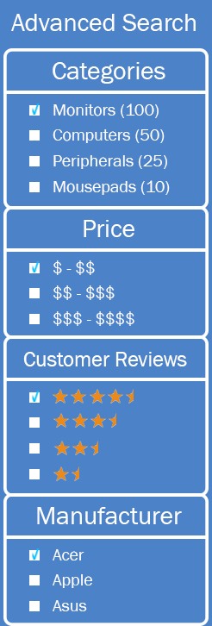

Figure I: High fidelity mockups of the filtering menu. The filtering menu will appear on the left side of the webpage, after a user has inputted a search query.

Figure J: Consolidated sketch of product filtering. The menu is meant to have a more readable format, as well as reveal more relevant filtering options for users.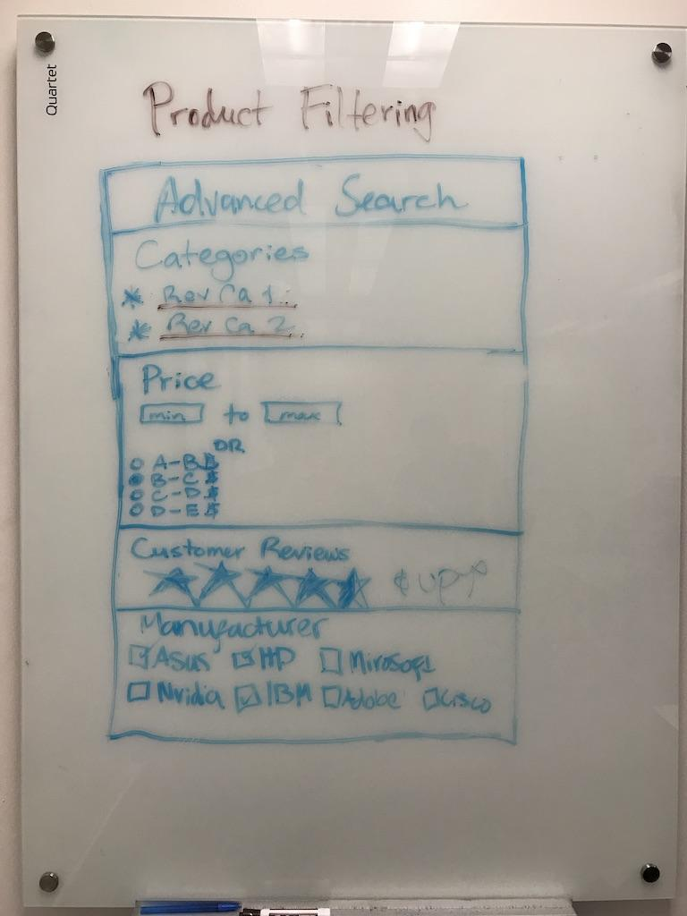

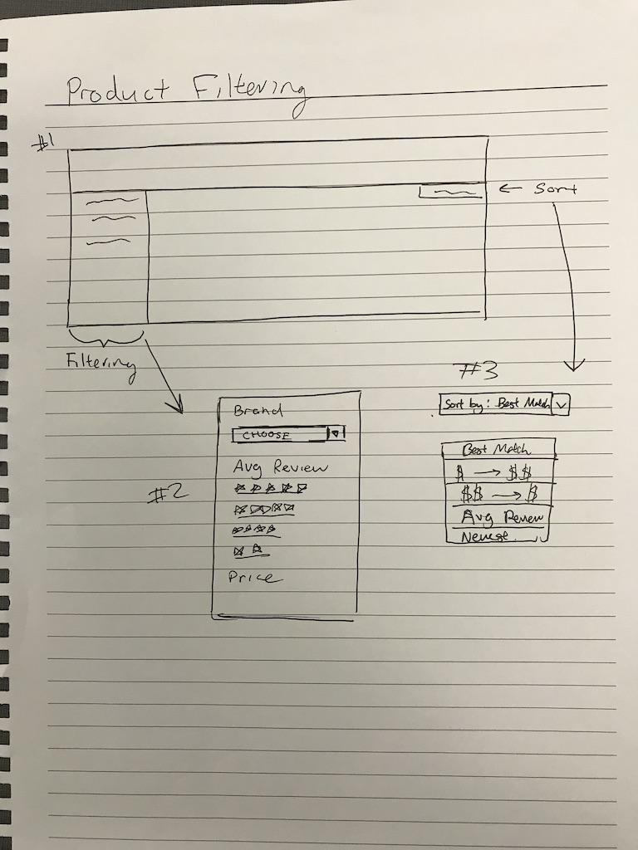

Figure K: Product filtering sketch (drawn by Jason Hing Lun Tam) displaying the location of the filtering menu on the webpage and possible basic filtering options.

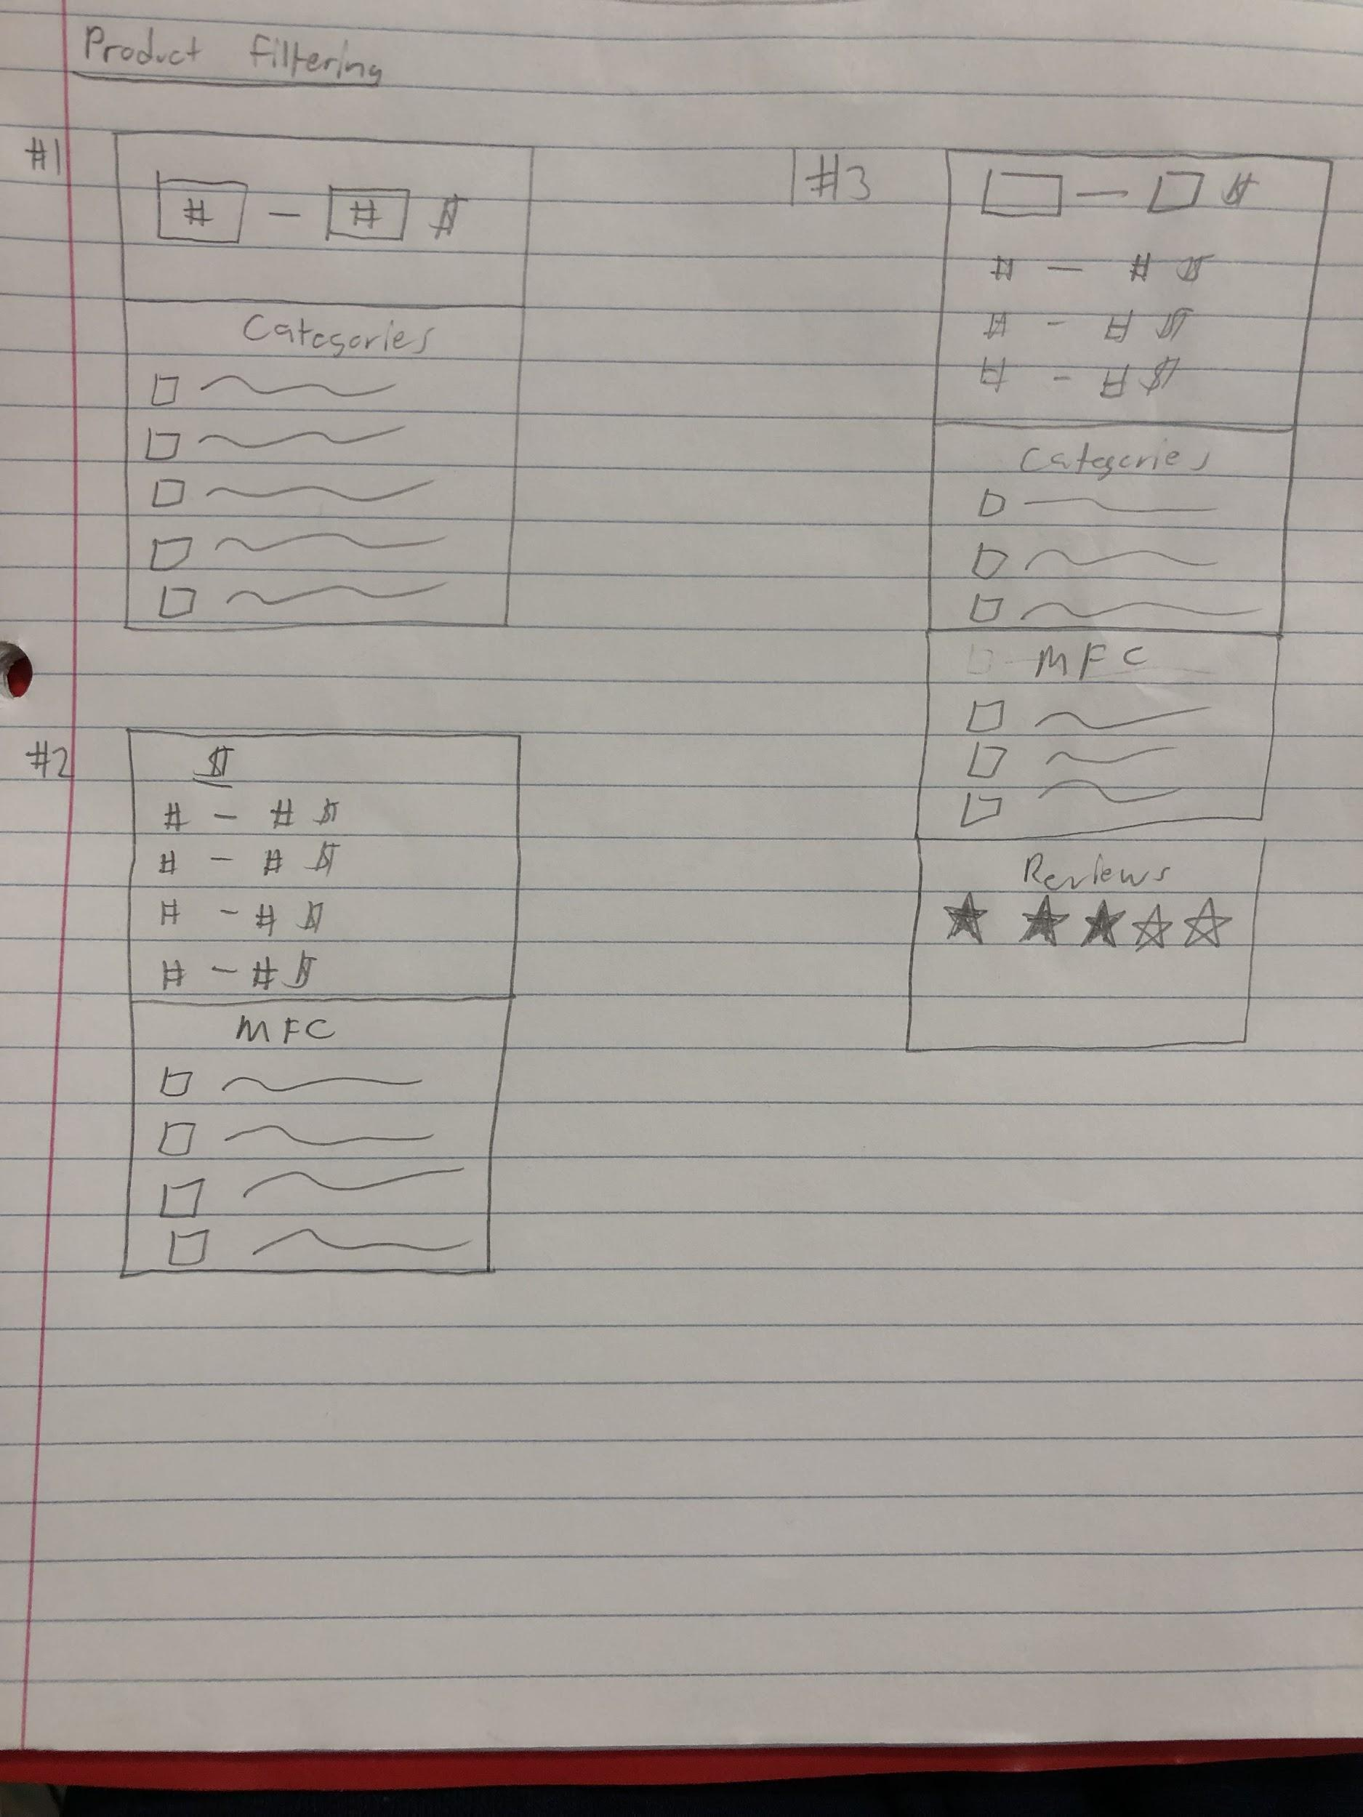

Figure L: Product filtering sketch (drawn by Juwan Michael De Jesus) showing the possible look and filtering options for the filtering menu of shopBLT.

## Design Documentation for Product Filtering

* **Problem:** As it currently stands, the product filtering menu is not clearly visible for the user. Rather than having the menu be instantly accessible to the user, the menu is placed at the bottom of the webpage after all the product search results. The user has to put in the effort of looking for the filtering menu if they want the opportunity to utilize it. Along with this, our user research demonstrated that the filtering options given to users were not so helpful either. As shown in Figure 12 (see appendix), the filtering menu has four options: manipulation of the search query, “Manufacturer”, “Catalog Group”, and “Price”. Within these four options, the metrics used to filter out the search results are unorthodox/non-standard. For example, in the “Price” option the metrics given to the user are “Anything”, “Equal or Less Than”, and “Equal or More Than.” In general, these metrics are not what people usually consider when looking for a product on a shopping website; they usually consider things like “Under $10” or “$50 & Above”, or a range like “$20-$30”. By addressing these issues we hope to provide the user with a more helpful filtering menu, which is what it originally was meant to be as a website tool.
* **Evidence:** When conducting our user research and doing usability tests on the filtering menu, we discovered that users either had a difficult time locating the filtering menu or did not find the filtering menu at all. When asked to find a product on the website that was within a certain monetary price range, users went directly to the search bar and manually looked for the product. One out of the five test-subjects actually used the filtering menu to find the product within a price range. But this test-subject also had trouble with the given options and metrics the menu gave them. Also when conducting our cognitive walkthrough, our team noticed that the actual functionality of the filtering menu didn’t work either. When we inputted a search query and only wanted the results for products that were “Equal or Less Than: $25”, the menu disregarded this input and still gave us all the products that were available; we had product results with prices like $30 or $40.
* **Process:** To help decide for the final redesign, we all put our sketches together and started picking different features from different sketches that we liked. In the end, this is how we decided what the redesign should look like and which would help users the most. The sketches for this redesign all had similar ideas in terms of what the filtering menu should look like and where it should be placed. All sketches of the filtering menu were in the shape of a long box and each filtering option had its own section within the box. Many of the sketches had the filtering menu on the left-hand side of the webpage. Common filtering options that were previously on shopBLT’s website were “Price”, “Manufacturers”, and “Categories”. But on the sketches, these options were altered and looked different than what shopBLT had them to be. For the “Price” option many sketches had text fields for the user to manually input a price range, along with a radio button group that had determined price ranges already. For the “Manufacturers” option, sketches had a checkbox group with names of different popular manufacturers that users can select from. For the “Categories” option, sketches had the names of relevant categories the product belonged to; users were able to click the category if they wanted to look for more similar products. A new category that appeared from many sketches, was “Customer Reviews”. Team members showed this part of the filtering menu as filled/non-filled stars, in a range of five.
* **Results:** Our final redesign for the filtering menu prioritized accessibility and functionality, as far as what it meant to be beneficial for the user. Our team’s motivation was to improve the website’s filtering menu in order to increase customer usability of the tool. First off we decided to make the menu more visible to the user, that way they wouldn’t miss it or have to spend unnecessary time looking for it. We decided to make it appear on the left-hand side of the webpage, after a user has already inputted a search query. As far as filtering options, we decided to keep some of the current options of the menu and improve their use of metrics to more orthodox/common metrics that users are familiar with. By allowing the user to choose relevant categories for the product or choose a price range for the product or select more than one manufacturer for the product, we’re allowing the user to have freedom and accurate search results. We also decided to include a new option that we think users will find more beneficial when trying to search for desired products. We found in user data that people want to see certain information when looking for a product, in order to help them decide whether or not to buy the product; providing information like customer reviews, allows the user to see which products are worth spending their time investigating. We wanted to make the filtering menu more familiar to users, just as they would see a filtering menu in another shopping website. Figure I is the final product of the newly improved filtering menu.

## Product Check Out

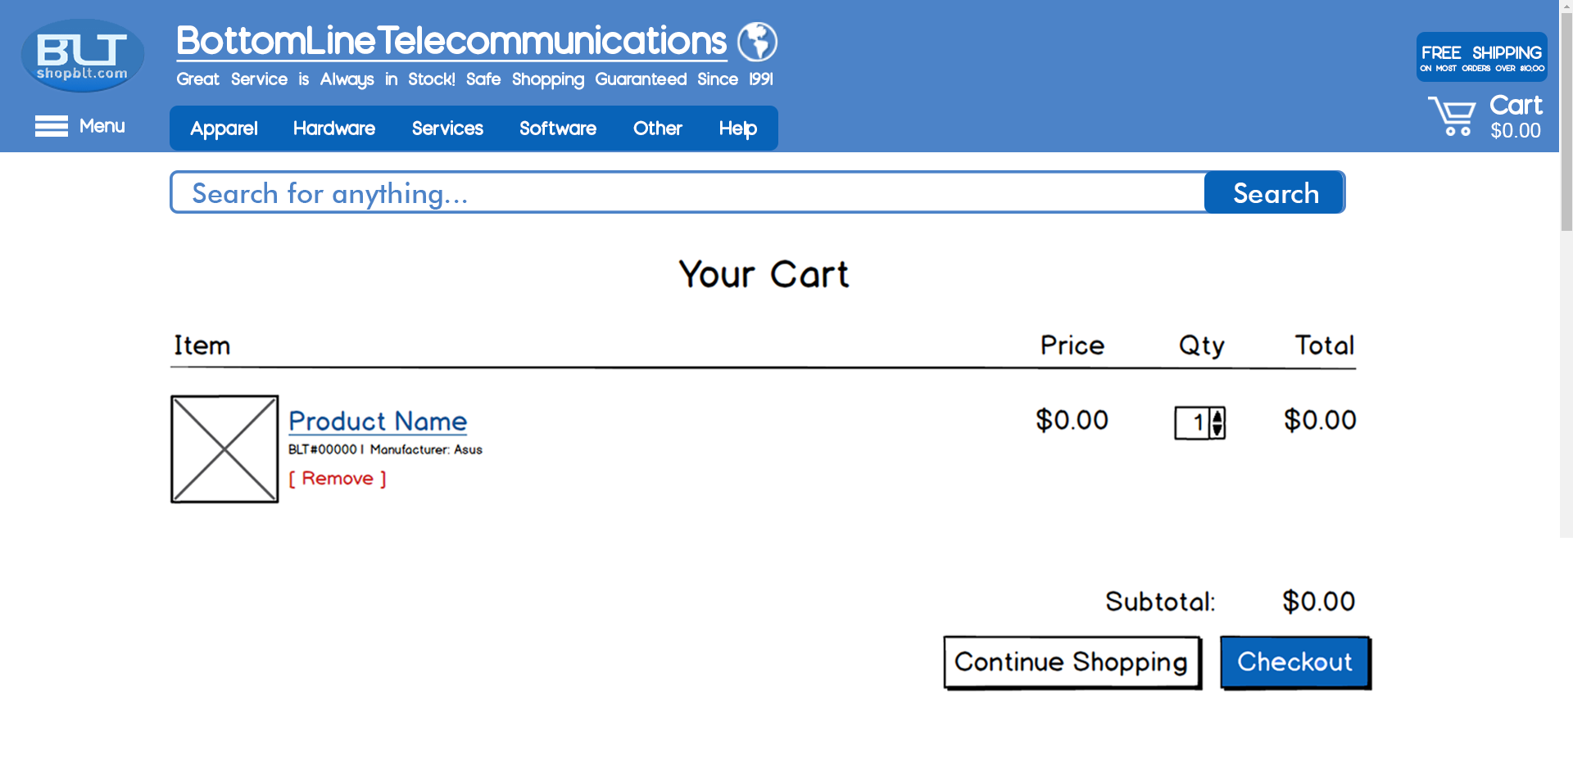

Figure M: High fidelity mockup of the **cart** to improve **product checkout**.

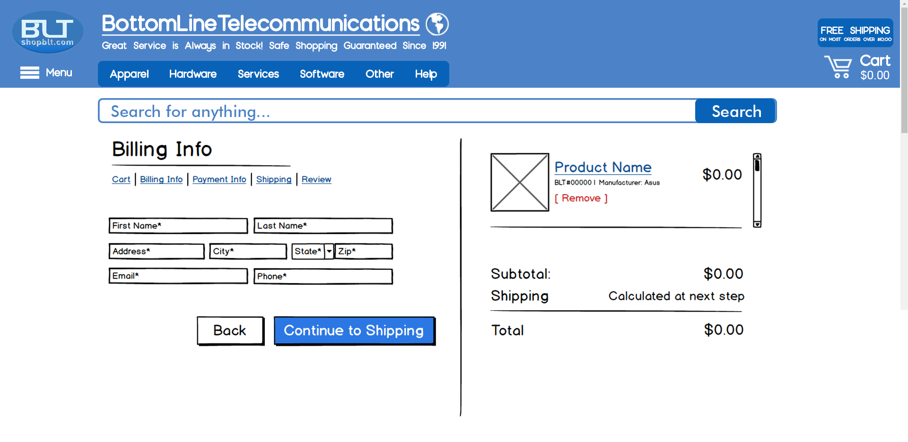

Figure N: High fidelity mockup of the **customer billing page** to improve **product checkout**.

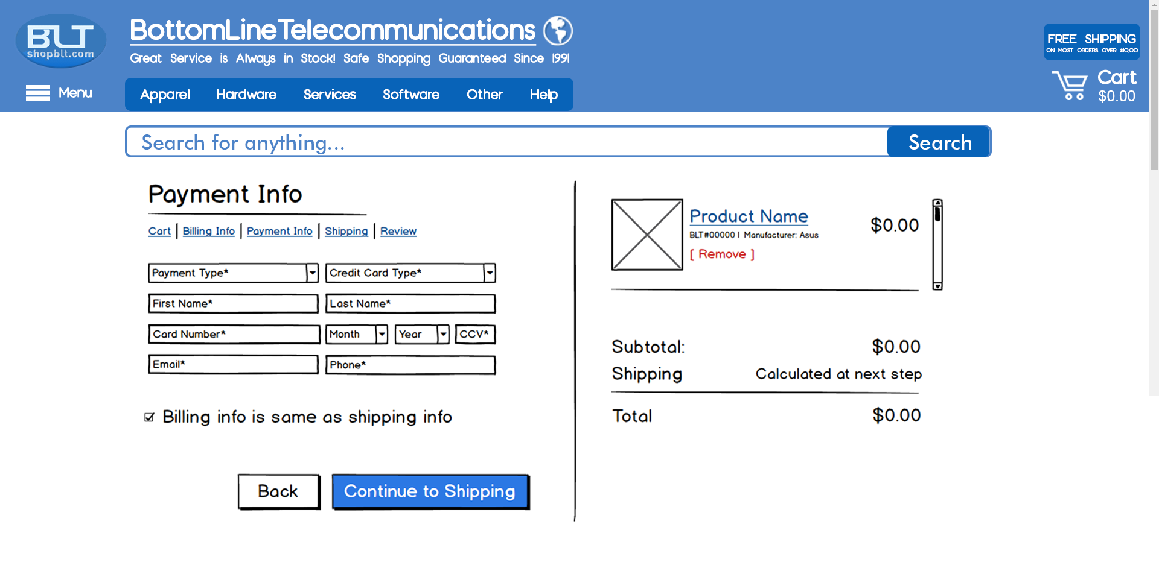

Figure O: A high fidelity mockup of the **payment info page** to improve **product checkout**.

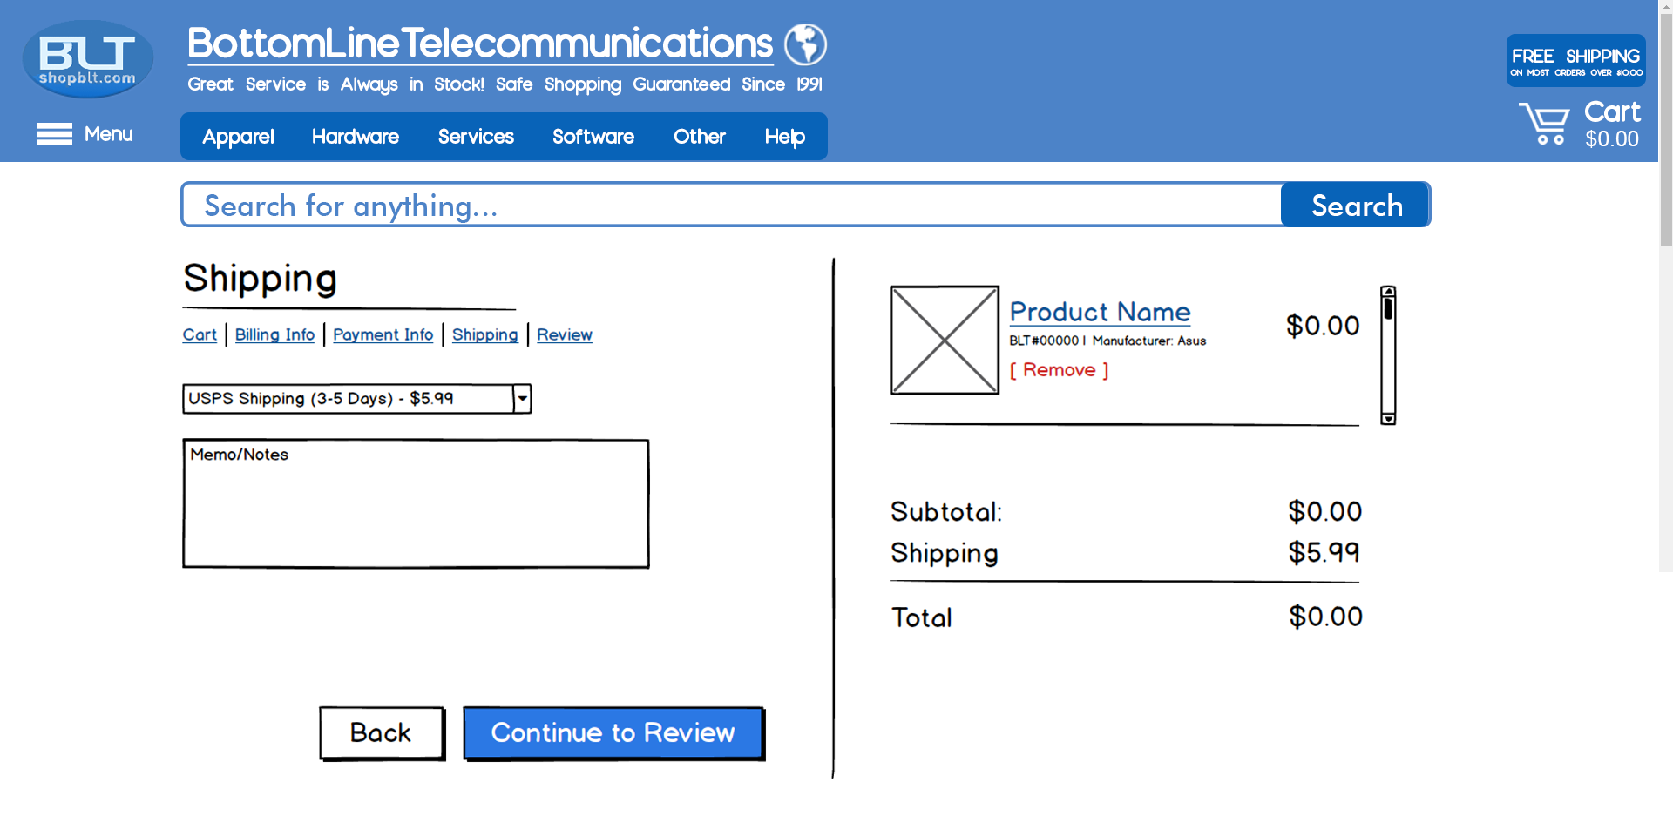

Figure P: High fidelity mockup of the **shipping page** to improve **product checkout**.

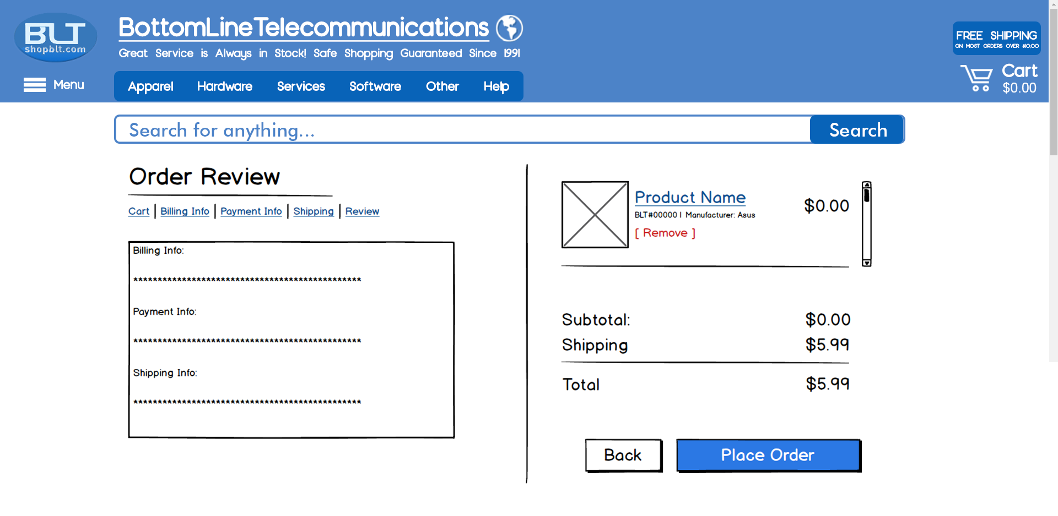

Figure Q: High fidelity mockup of the **confirmation page** to improve **product checkout.**.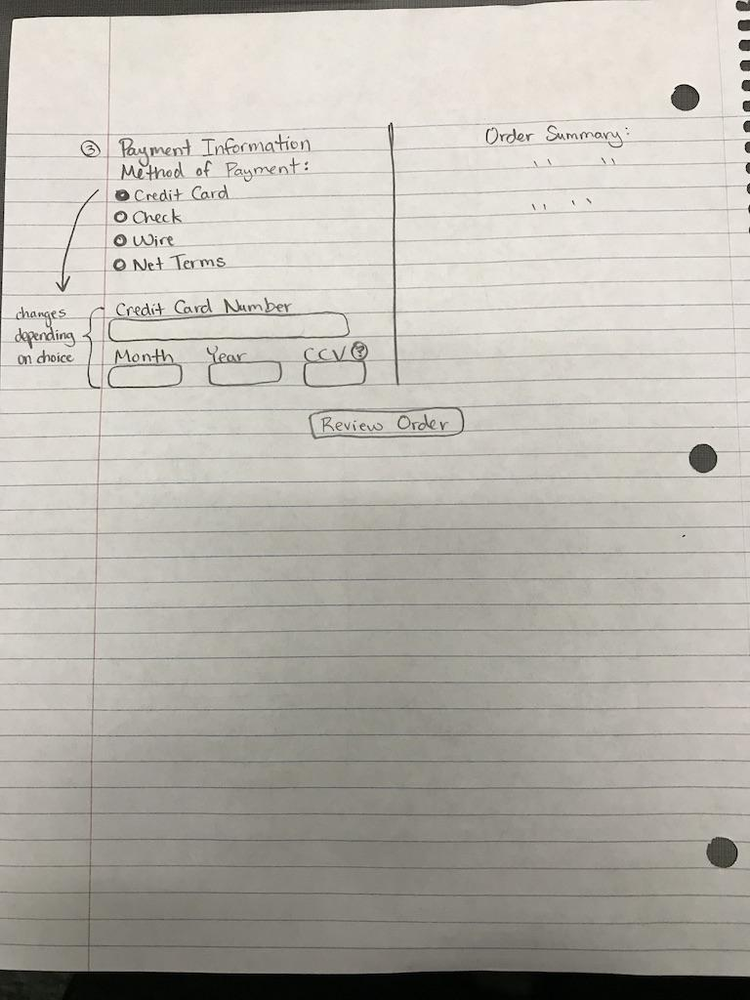

Figure R: Sketch of the payment page in the checkout process (drawn by Alonso De La Torre).

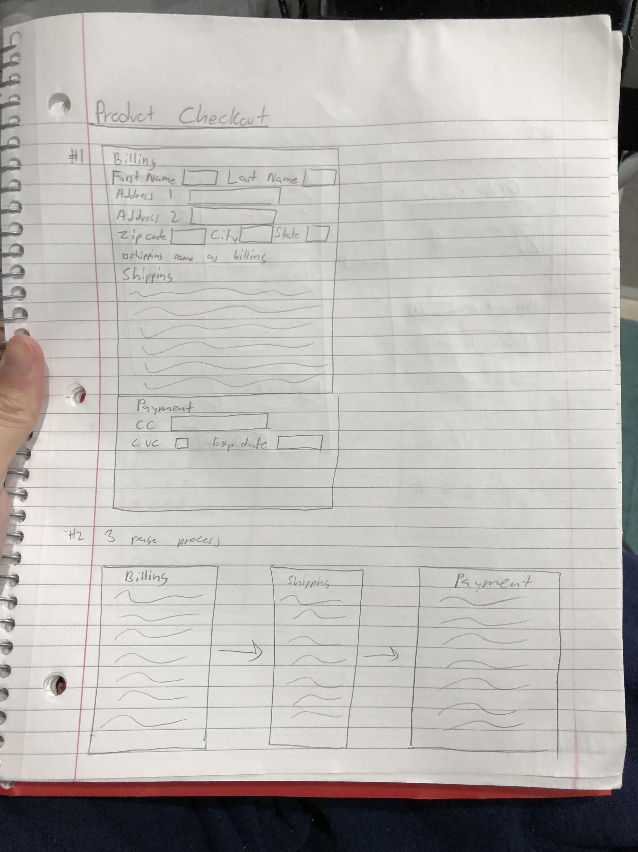

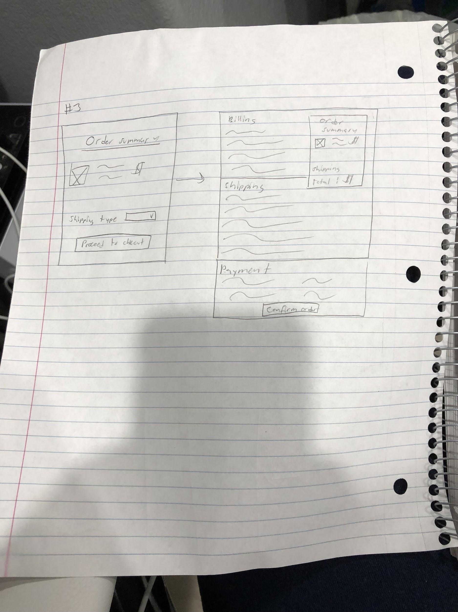

Figure S: Sketches of the checkout process (drawn by Juwan Michael De Jesus)

## Figure T: Sketches of the checkout process (drawn by Jason Hing Lun Tam)

Figure U: Sketch of the shipping method page as part of the checkout process (drawn by Jason Hing Lun Tam).

## Design Documentation for Product Check Out

* **Problem:** The current checkout process for shopBLT is out of date and takes the user through several pages that can be seen as redundant and unnecessary. When initially going to checkout, the user is overloaded with a plethora of information, some being unimportant or irrelevant to the user (ex. wait or the manufacturer number). Additionally, on the first page of checkout, the user is met with a secure checkout and regular checkout option. The secure checkout seems to be the first pick for most users but the issue is that these two buttons take the user to the same place - it does not make sense as to why both exist in the first place. After selecting one of these options, the user is taken into a page denoted for reading the terms of services. Most users will not care to read the terms of services, creating an extra page the user has to navigate through. Once the user advances forward, they next fill out the basic information such as shipping and billing information. However, in some cases, the user is forced to have an email that is not provided by a free email service such as Gmail or Yahoo. This is an issue since most common online shoppers use free common email websites. If a user is unable to successfully provide an email or does not have access to one, then they will feel obligated to leave the site and purchase the product elsewhere.
* **Evidence:** Product checkout is one half of the ecommerce purchasing process. It is the second most important part of a user’s buying process, the first being product discovery. Since checking a product out and purchasing it is so important, we felt it was necessary to ensure the effective usability of this experience. Our new design pulls inspiration from simpler and newer checkout processes. We derived most of what needed to be changed from our Usability Tests, in which users were observed having trouble inserting predetermined data into the website’s current checkout process. We believe from expert analysis that purchasing a product should not take longer than 5 minutes. From our testing however, we saw that users consistently took longer than 5 minutes when attempting to insert information. We also saw from our findings that this problem could be due to a lack of accurate signifiers; users were slowly moving their cursors and found the next info box in a slow and steady manner.
* **Process:** Most of our designs were very similar to the designs we have used in our own ecommerce experiences. The designs are reminiscent of Amazon, eBay, and PayPal checkouts. We all made multi-page designs, which required “Next” buttons in order to advance to the next step in the check out process. We eventually decided on this simplistic design, since it would provide a simpler checkout process while still leaving the site looking similar to the original. We also decided on adding different form boxes and less clutter. Instead of endless entry boxes, dropdown boxes and checkboxes are here. Instead of unnecessary text everywhere, we opted for a clean design with minimal typography. We found that dropdown boxes and text boxes were easier for our users to use rather than the radio buttons some of us drew in our original sketches. We also opted to keep our design with a product summary on the side at all times so the user knew what they were purchasing. We put our sketch designs on the left side and the summaries on the right.
* **Results:** Our redesign attempts to split up the checkout process from a long scrolling page of information to a paginated design. Figures M-Q show the logical process from first step in cart to last step of order review. Figure M shows the cart itself, which is simplified to show a picture of the item, the title, the BLT number, the manufacturer, the price, and the quantity. At the bottom, there is a continue shopping button, followed by the actual checkout button. Clicking the checkout button will take a user to Figure N, the Billing Info page. Here are entry boxes that are relevant to the billing of an item. On the right is the summary of the process, showing the same info as Figure M at all times. After clicking, “Continue to Shipping”, the user will be taken to Figure P, which is the Shipping page. This page contains different shipping options in a dropdown menu, along with a text box for memos or any other information for BLT managers to know about this shipment. This, we believe, helps cut down on superfluous text and options in the checkout process. Included as well are all of our relevant sketches, which display our thought processes during the storyboarding process.

## Search Bar

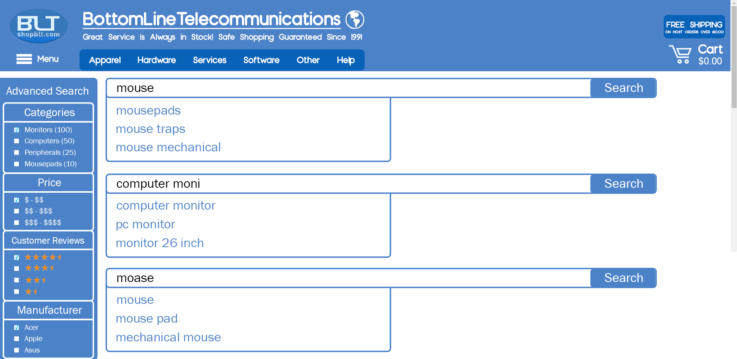

Figure V: Mostly relating to the logic of the search bar, we can see search attempt to guess what the customer is trying to put in the search bar for three different instances.

### 

Figure W: The consolidated sketch on the logic of the search bar.

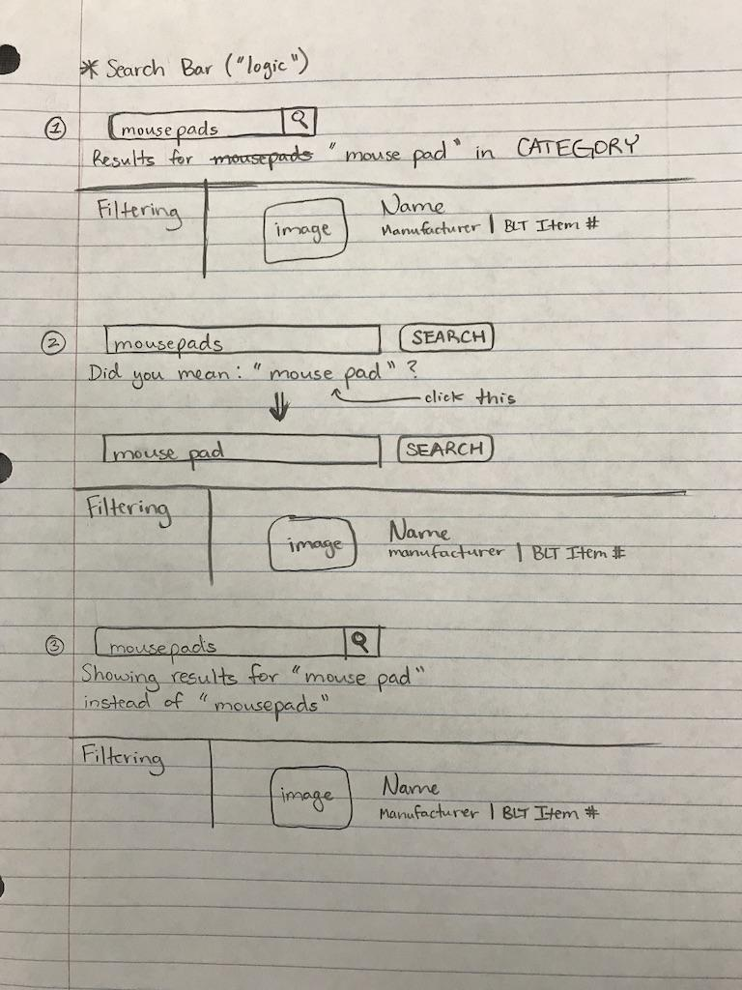

Figure X: Sketch detailing the logic of the search bar.

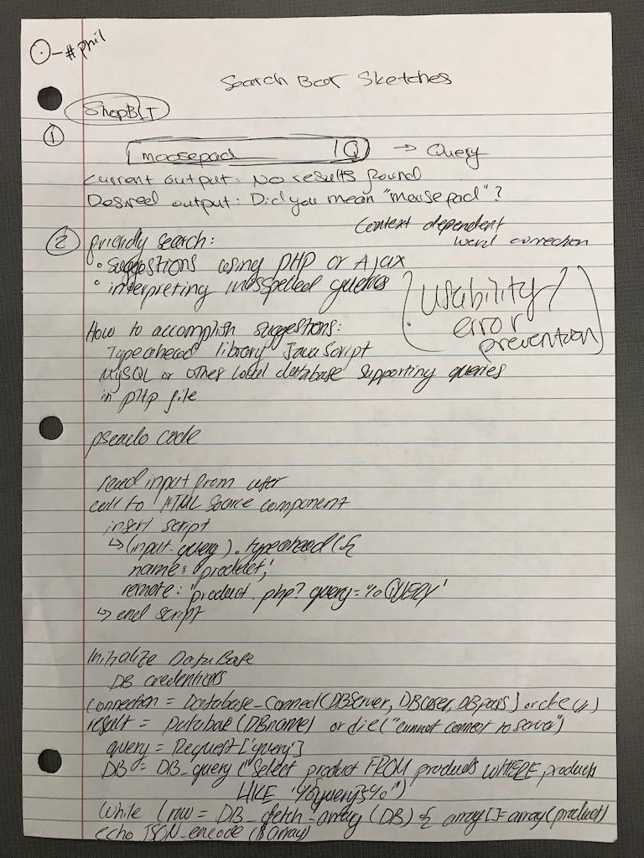

Figure Y: Sketch Detailing the problem assessed and the pseudocode for the implementation of the search bar logic.

## Design Documentation for Search Bar

* **Problem:** The problem we found in the past assignments was the search bar algorithm—or rather lack of one. It was unable to understand anything besides exact keywords (i.e. “mousepads” would not turn up any results, but “mousepad” did). A potential customer could want to see what mousepad shopBLT offers and may put “mousepads” only to be met with no results. For a better user experience, we also wanted the search bar to show suggestions for multiple occasions: one such occasion is one where the user types in a word and the search bar shows related suggestions (i.e. “mouse” would return “mouse pad” and “mouse trap”). It is important to make the process as easy as possible so that the customer can quickly and easily purchase products. The other occasion would be when the user types in a query that has a spelling error. In this scenario, the search bar would show the suggestion “mouse” when the query would be “moose”. It is very helpful to account for misspelled words as even the most skilled spellers and keyboardists make mistakes.
* **Evidence:** During our cognitive walkthrough, usability tasks, and general use of the website, we discovered that this issue could potentially turn away customers from buying a product simply because they did not give the exact query. We also wanted to attract more customers by making their user experience easier, therefore, offering them suggestions when they misspell a word and offering them suggestions of the most sought after items to help the user.
* **Process:** We came to the conclusion that there was not really anything wrong with the search bar visually - only logic needed a redesign. Since we all agreed on its logic and with the guidance of Hillary and Professor Bietz, we all agreed to sketch out the logic of the search bar. When we all met with our sketches for the search bar logic, we were able to consolidate our ultimate sketch detailing its scenarios and how it catches errors. THis ultimately enables customers to have an easier user experience and attract more business.
* **Results:** Lastly, the new design accounts for the consolidated logic of the search bar created by the team. On the current website of shopBLT.com, the search bar does not have any form of error checking for the user. It also does not offer any suggestions to ease the user experience. The new search bar will account for simple queries such as recognizing “mousepads” as “mousepad”. It will also account for misspellings of queries as well, realizing “moose” as “mouse”. The logic for the search bar should also be able to do even both of those “moosepads” should return the result of “mousepad”.

# **Appendix**

## **Problem Space:**

### Screenshots: Search Bar Query and Results

# 

Figure 1: Correct query for mouse pads using a specific keyword that the algorithm processes properly.

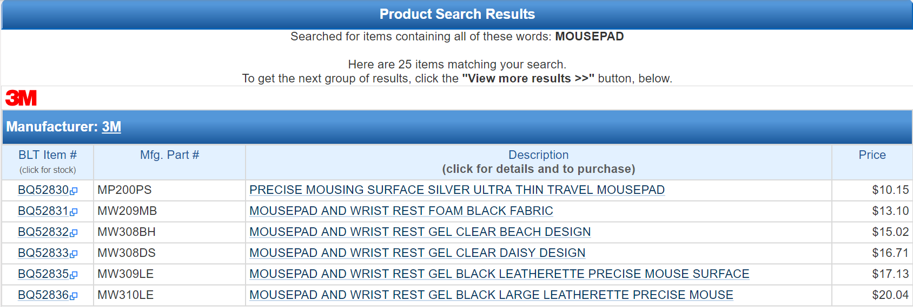

Figure 2: The resulting product listings from the query. Product listings are grouped by manufacturer and only one manufacturer is shown here.

Figure 3: Incorrect query for mouse pads using a keyword that is processed incorrectly by the indexing algorithm. Produces incorrect results.

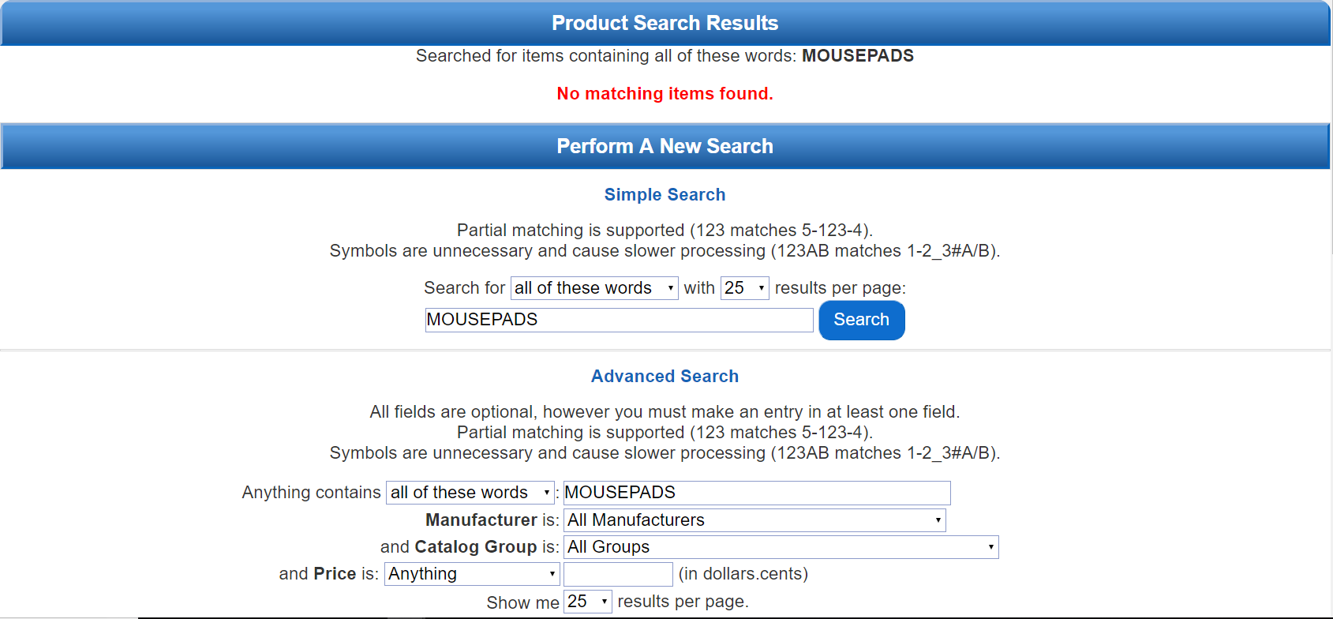

Figure 4: Resulting page for the query “mousepads”. Produces a false negative indicating that no matching product listings exist in the BLT inventory.

### Screenshots: Contact Information & Customer Support

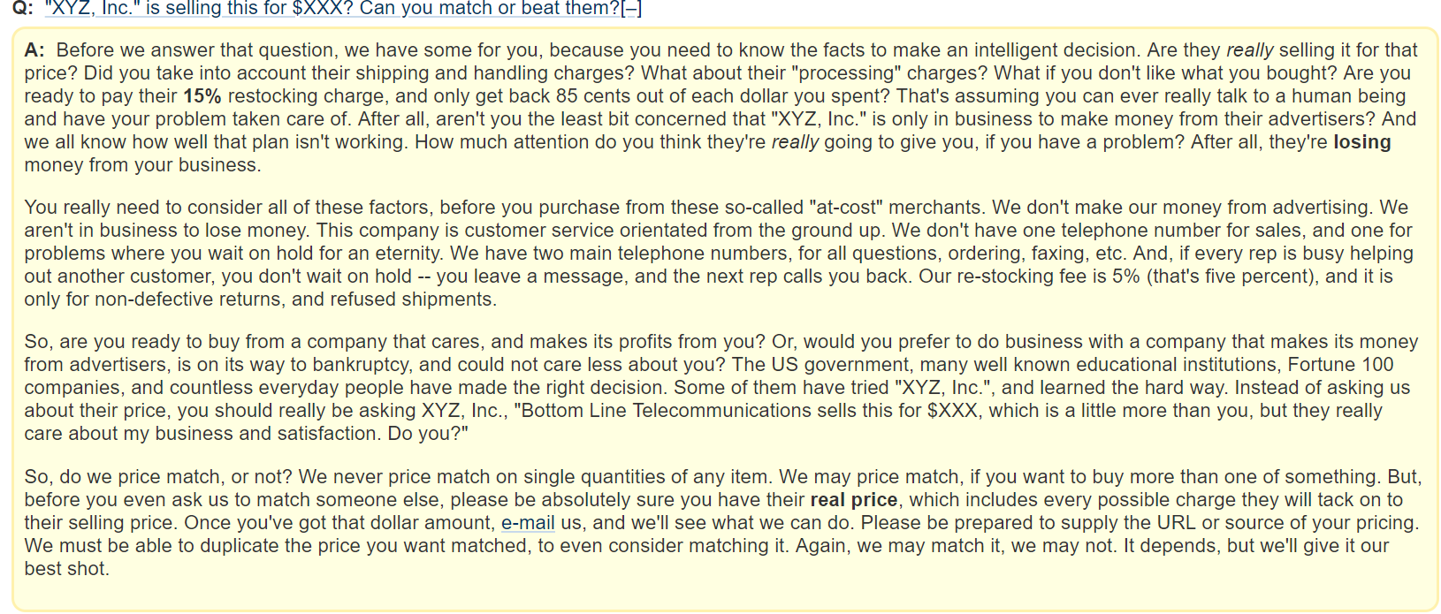

Figure 5: Depicts the frequently asked questions section. Note the excessive text to answer a question *frequently* asked by customers. The verbiage, terminology, and presentation of the answer fosters an inhospitable environment countering claims for great customer service.

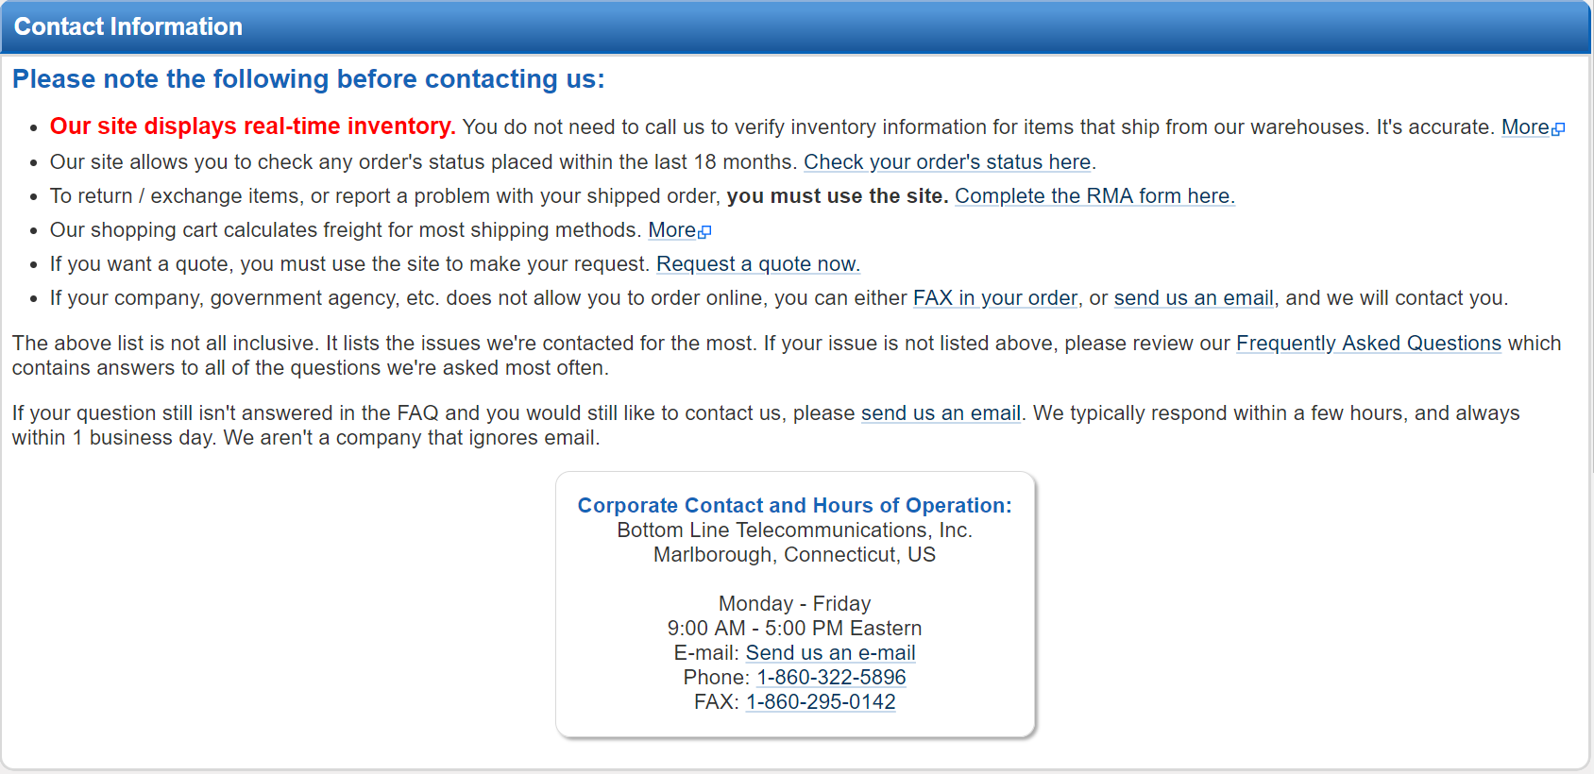

Figure 6: This is a landing page providing links to other resources for users. This page highly encourages that the user *not* contact customer service before reading all information on this page and in the frequently asked questions page. The phrasing here suggests in a less than subtle way that common customer queries are not a priority for customer service.

### Screenshots: Product Discovery, Visibility, and Listings

Note: **Product visibility** refers to actually product images and information that communicates appearance, structure, and form to the user. Important features include shape and scalable size. **Product discovery** refers to how users find and discover products that they might need or want. **Product listings** refers to the display of products from a search query or from navigation via the categories feature tool. Important features include, readability, visibility, and organization.

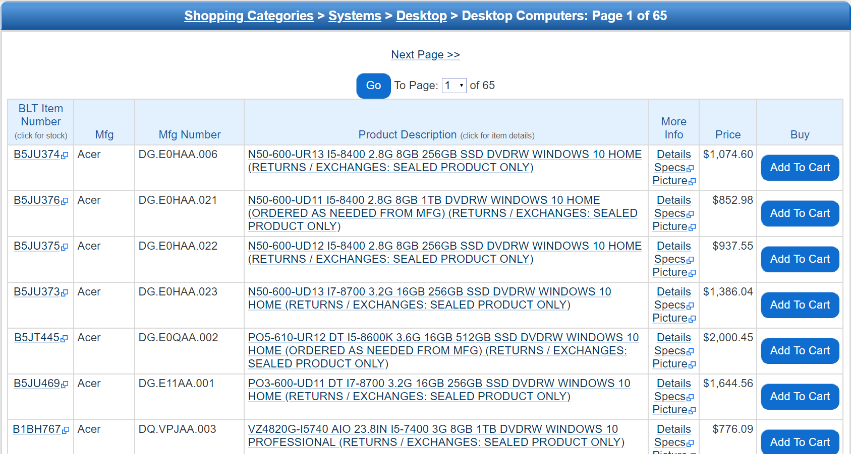

Figure 7: Relates to **product listings** and **product visibility**. Product listings are structured into a table format. The first three fields read information that is irrelevant to most users. Though the product description is centered in the frame, the listing descriptions are long and verbose. Product visibility is low here as no listing has a corresponding image.

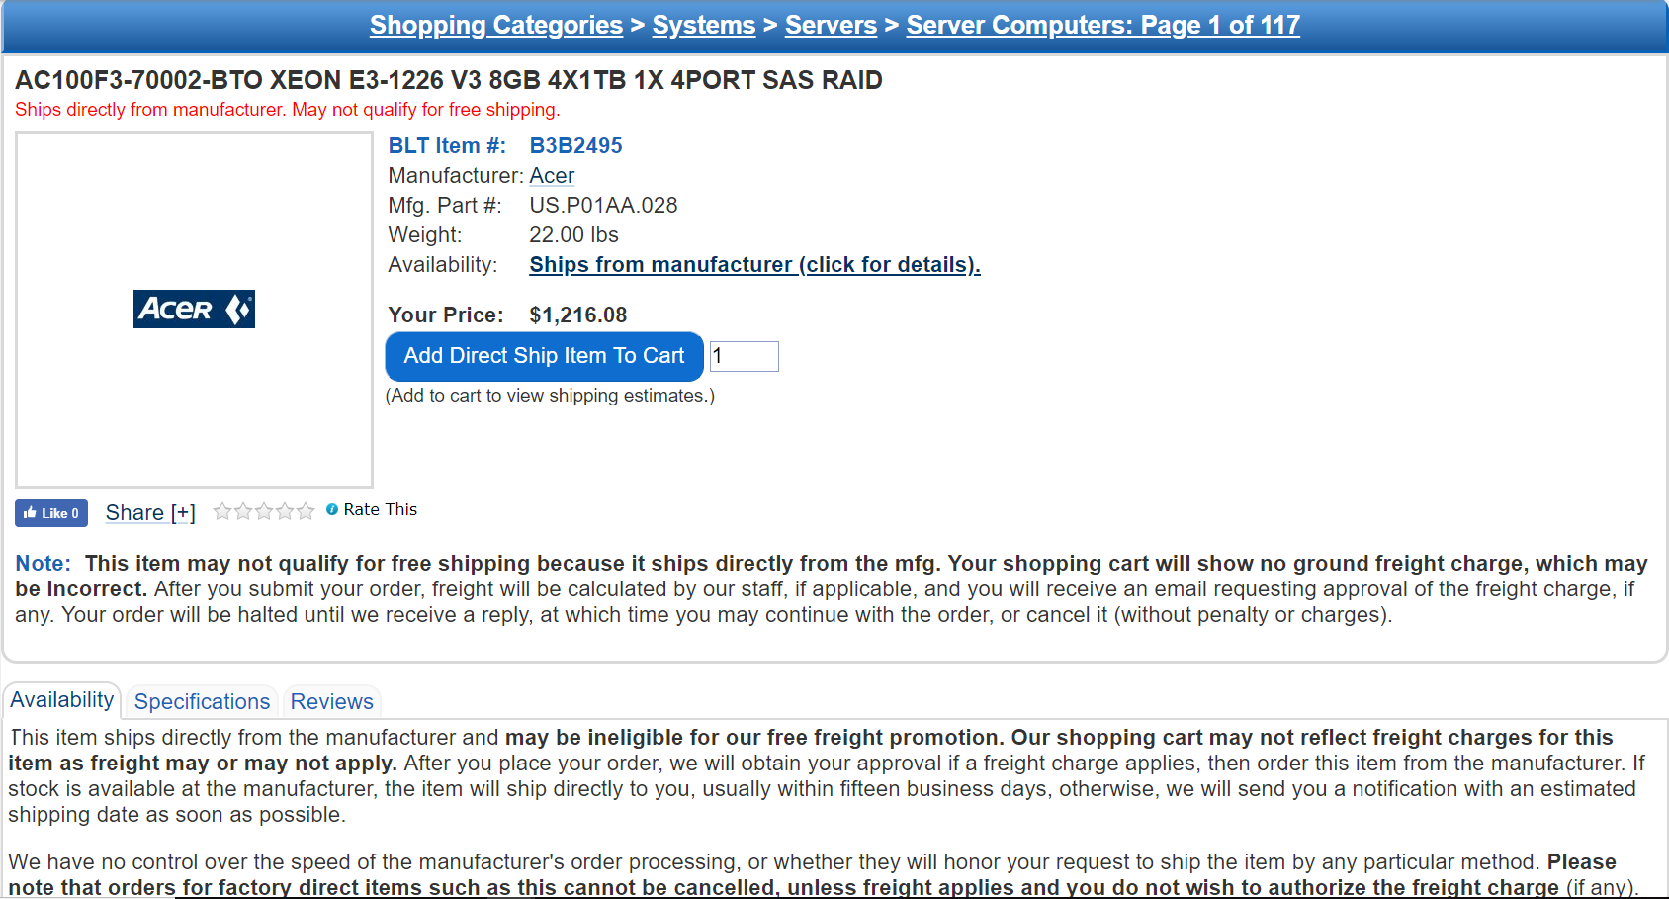

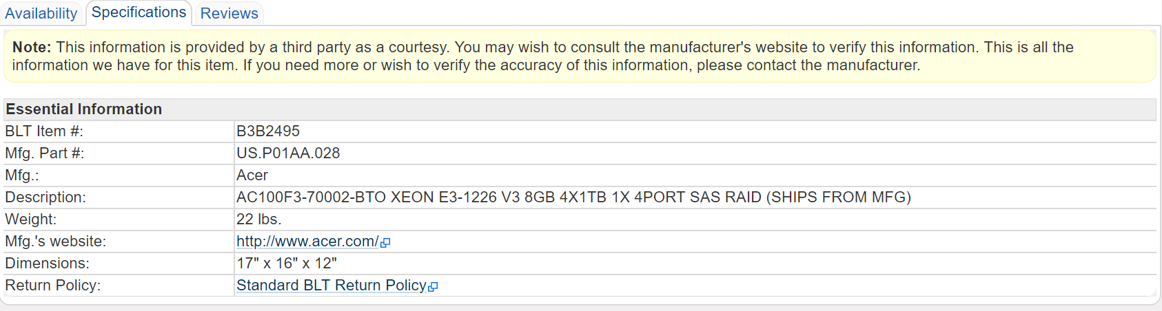

Figures 8 & 9: Relates to **product visibility**. The product page does not have an image for many associated items. The specifications tab also lacks descriptive details, which would provide the user or customer with a better idea of the product and what to expect when purchasing. Inserting images and appropriate details would improve the user experience by providing the tools to conceptualize product details and information.

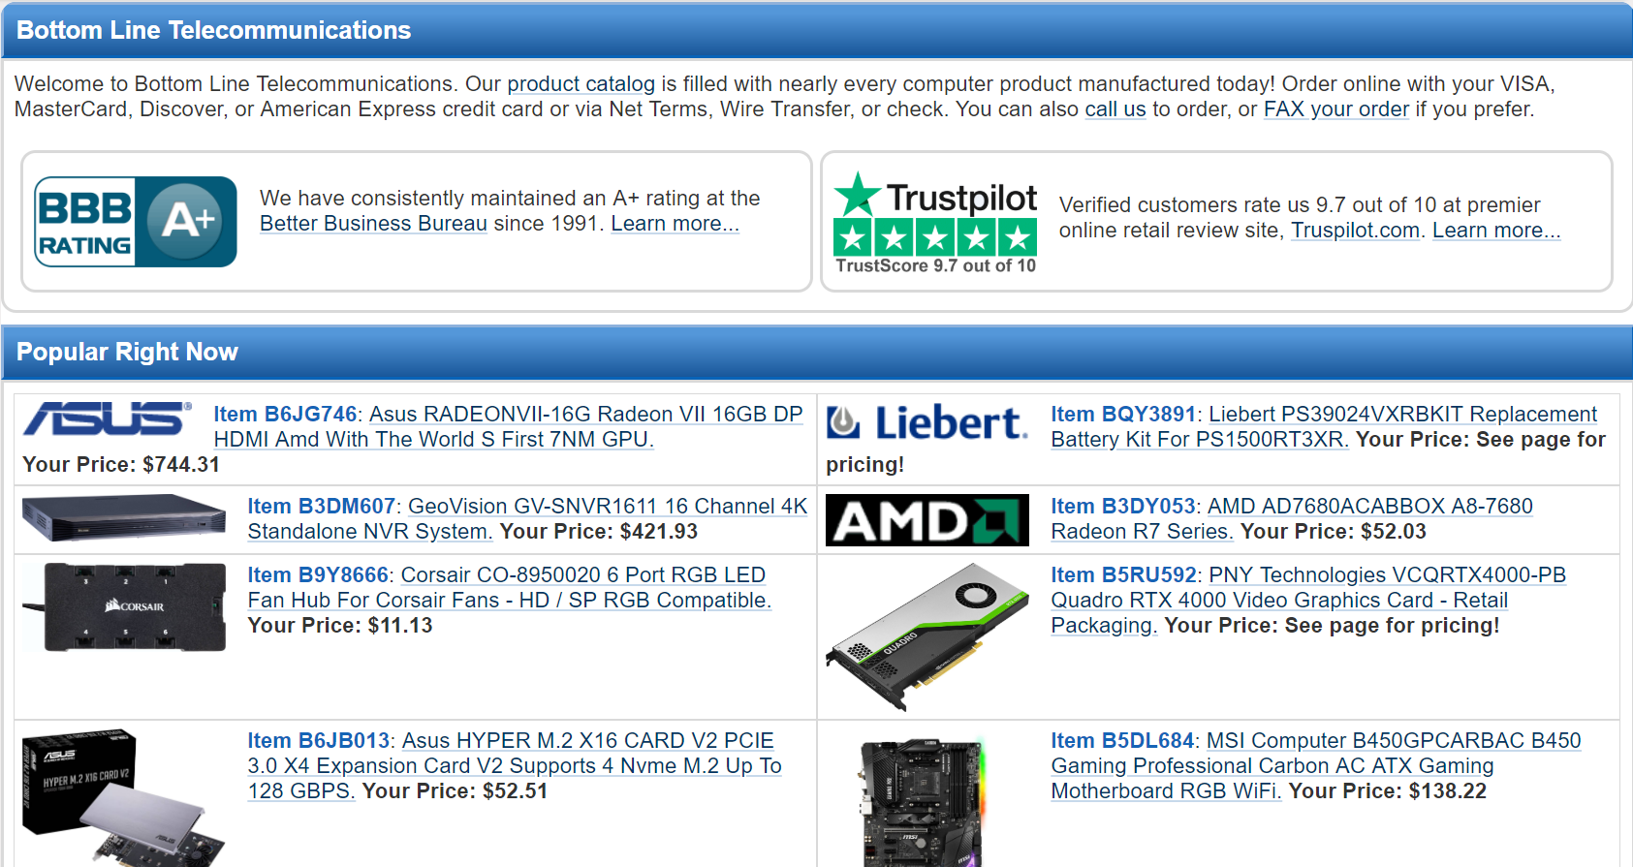

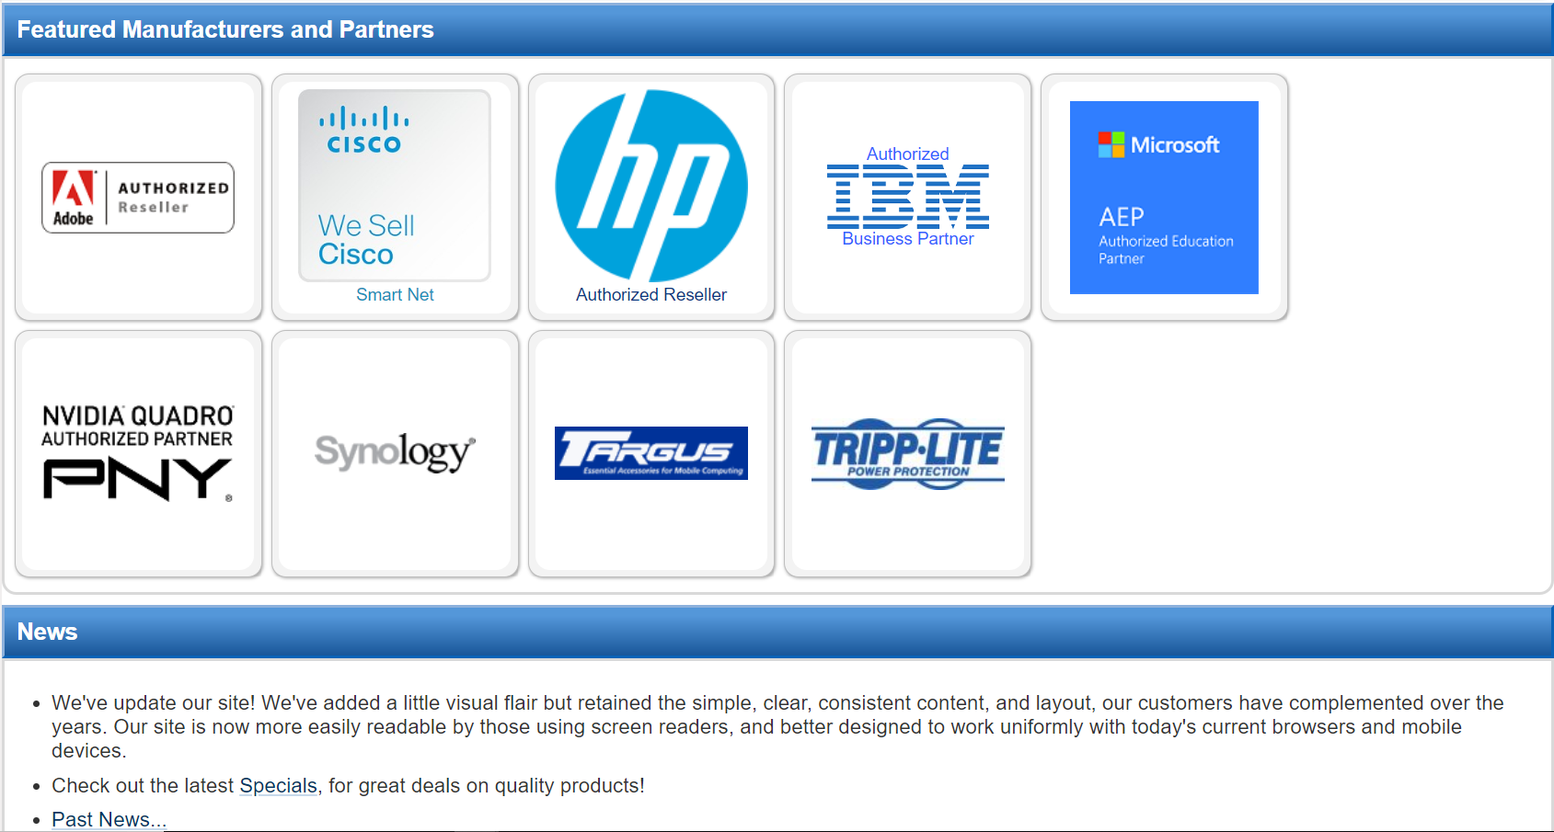

Figures 10 & 11: These images related to **Product Discovery**. The above images represent the entirety of the product listings on the homepage of shopBLT. This is one of the only sections on the website where product images are clearly displayed. Additionally, the website promotes its reputation to establish credibility. These features aside, the homepage does not allow much interactivity, nor does it entice the user or with a dynamic toolset to discover products they may want or need.

### Screenshots: Product Filtering

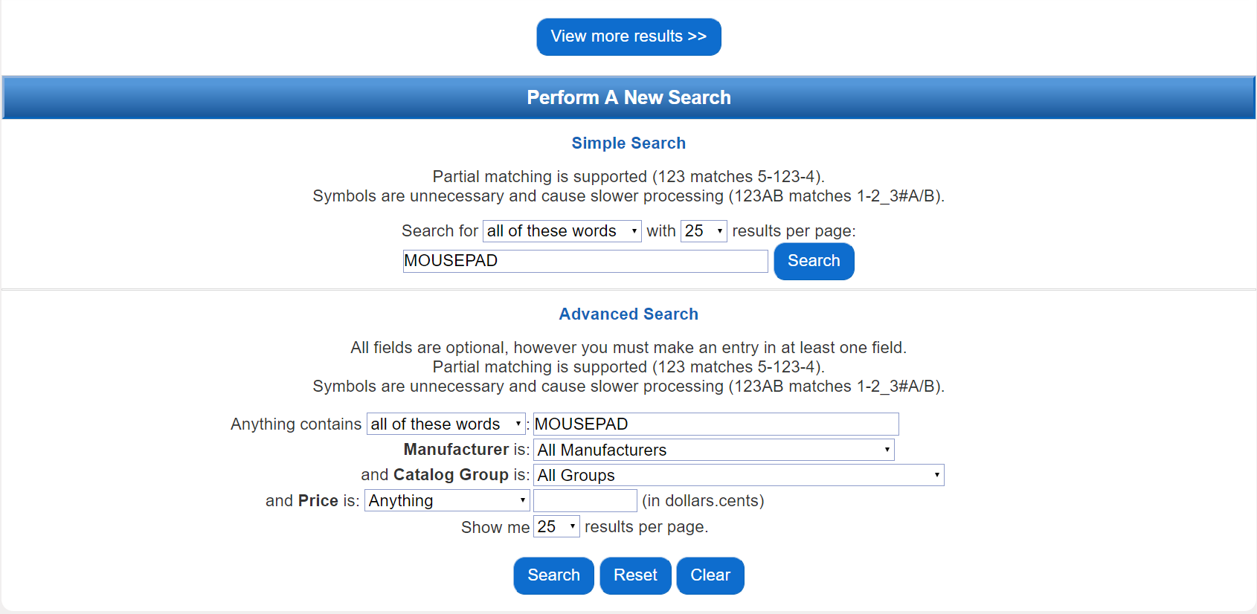

Figure 12: Represents the current product filtering feature deployed on the website. The tool is designed with metrics that are unfamiliar to most users. Furthermore, the volume of text and multiple text and drop-down fields clutter the tools interface, making it difficult to parse the necessary steps to successfully apply a filter to product search results. The positioning of this tools is also a weakness, it is located at the bottom of the page, beneath the search results. We have data supporting that user discovery of this feature is low.

### Screenshots: Product Check Out

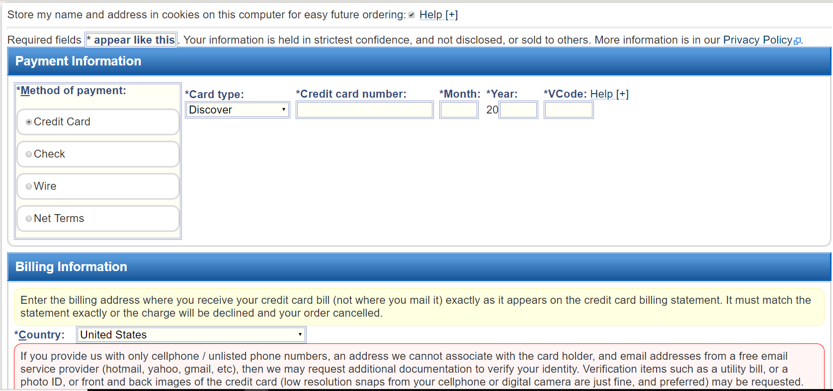

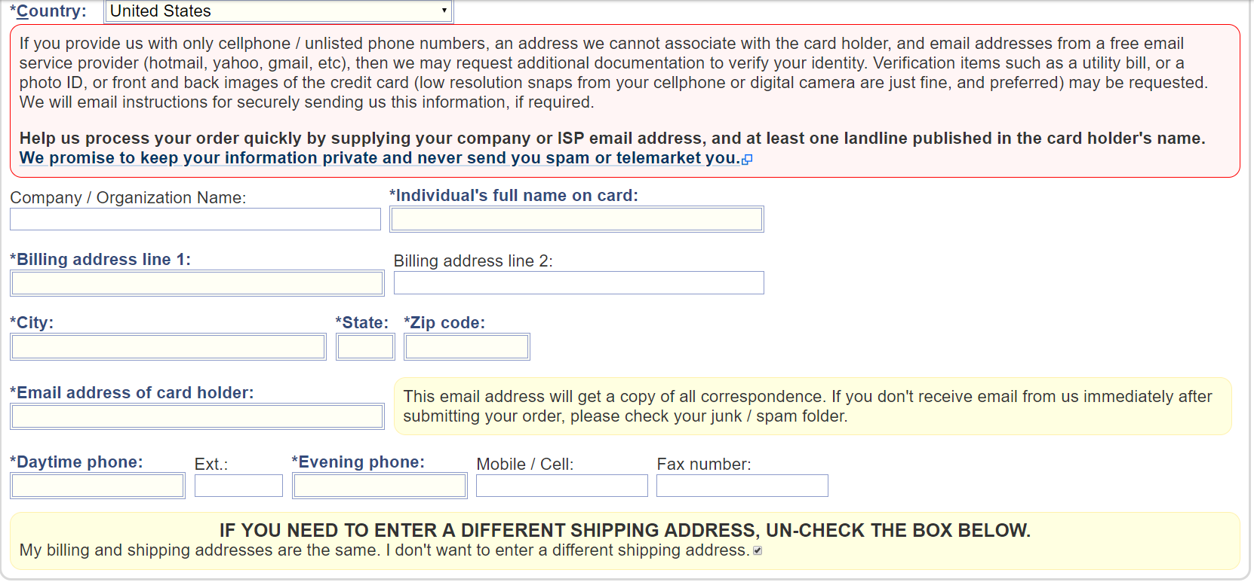

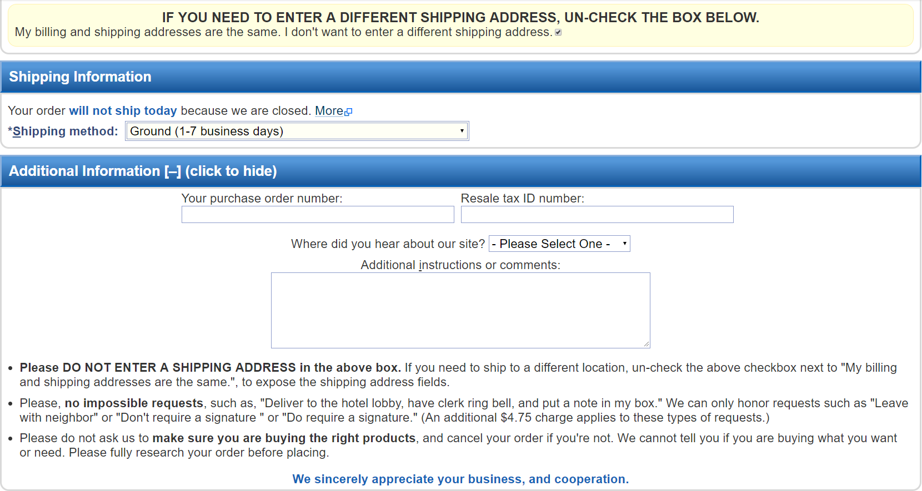



Figures (13 - 16): These images depict the entirety of the checkout process. Users data reports the interface is unnecessarily verbose and proposes too much information. Partitioning the checkout process could prove to be beneficial, as it would lessen the cognitive load on the customer and present a more streamlined user experience.

## **Consolidated Designs:**

### Customer Service/Contact Information

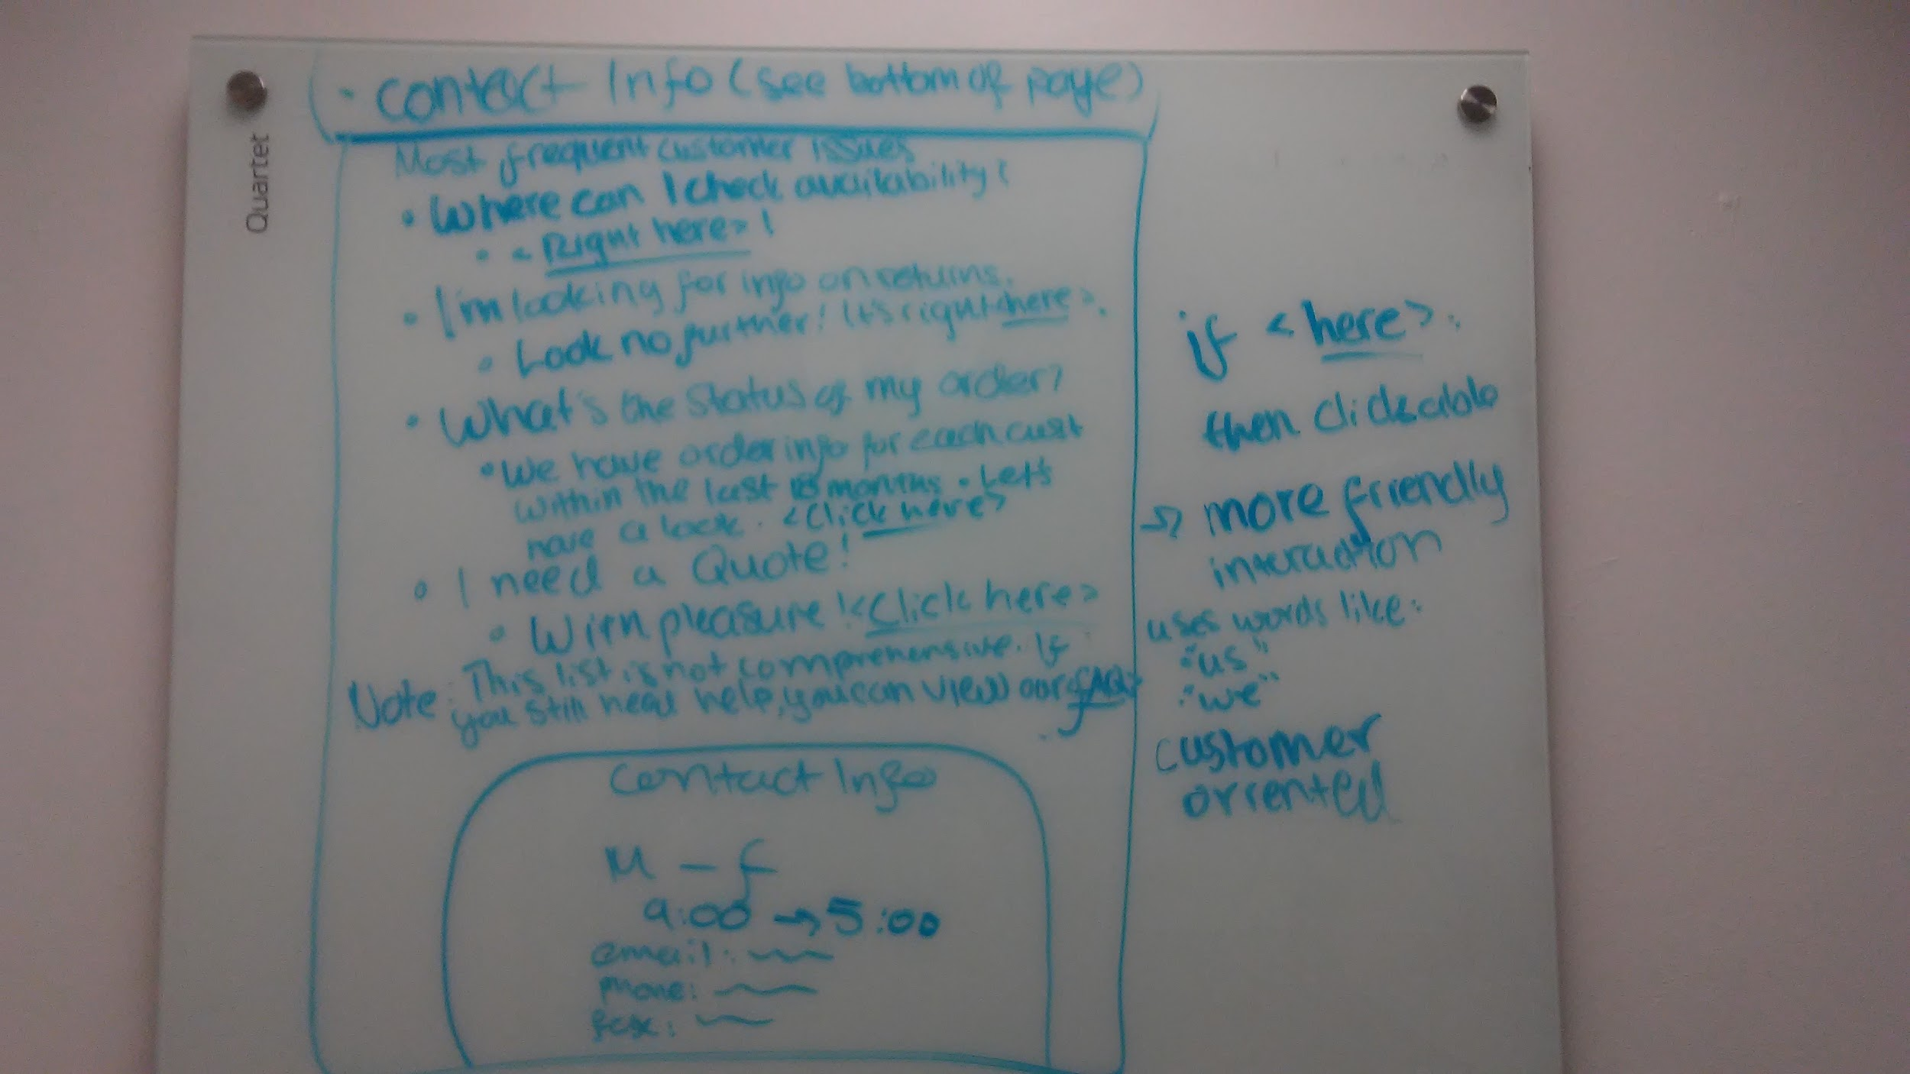

### Search Bar

### Product Visibility/Product ListingsProduct Discovery

### Product Check Out

### Product Filtering

## **Team Sketches:**

### Matthew’s Sketches

1. <https://drive.google.com/a/uci.edu/file/d/1-r_nPBD6P8jg5R-FobYJK7RKuGHNDd65/view?usp=sharing>
2. <https://drive.google.com/a/uci.edu/file/d/124JUpBKsKIBrYRctMHzQF6xgA4ilUSPj/view?usp=sharing>
3. <https://drive.google.com/a/uci.edu/file/d/16Ctzpa4dx1xUhEnA5hyhIuhN2MWowm_K/view?usp=sharing>
4. <https://drive.google.com/a/uci.edu/file/d/1L3K8X1p1HAJnjVnUSWcjVEk3Ehib4C90/view?usp=sharing>
5. <https://drive.google.com/a/uci.edu/file/d/1NzsJq0NcxJtoqepGHLhtq0U79Fd2TmTQ/view?usp=sharing>
6. <https://drive.google.com/a/uci.edu/file/d/1OyQc_ExyKdKWDGgEWHPTtpVMuDqq7yFP/view?usp=sharing>
7. <https://drive.google.com/a/uci.edu/file/d/1TaUz7g85FAsKiug4_P4vJtUvsyCkB8gp/view?usp=sharing>
8. <https://drive.google.com/a/uci.edu/file/d/1aftlLR_wqQCcDz7rRh9-YzkqsVchwYA1/view?usp=sharing>
9. <https://drive.google.com/a/uci.edu/file/d/1ePca35qpzBCTXdP6NyuYJctnFiCzpOC-/view?usp=sharing>
10. <https://drive.google.com/a/uci.edu/file/d/1hAunvt_2G0qgEwkXH1qdN85C_7pyxMU7/view?usp=sharing>
11. <https://drive.google.com/a/uci.edu/file/d/1maMjI-tnu011x97GMIrk0xh-g9Taozrb/view?usp=sharing>
12. <https://drive.google.com/a/uci.edu/file/d/1mrcUetdhDjIhkeR2LqGVenFRbpoXnTF_/view?usp=sharing>

### Alonso’s Sketches

1. <https://drive.google.com/a/uci.edu/file/d/1-AF2wHbcZQ8EPuLllB-4QasJR20gpJ8P/view?usp=sharing>
2. <https://drive.google.com/a/uci.edu/file/d/1Oagq3BhqU_QLFd7c-h6xi3-XtWbwWdWg/view?usp=sharing>
3. <https://drive.google.com/a/uci.edu/file/d/1QYytVCb4G5W92MBtSUTpks93-VtE4wEm/view?usp=sharing>
4. <https://drive.google.com/a/uci.edu/file/d/1ROodlMyXsfmE_9IyQ_FONM_6N_HHEFSG/view?usp=sharing>
5. <https://drive.google.com/a/uci.edu/file/d/1itE_AnxLyKT7LyEpSuBzV26dnFBLbR4O/view?usp=sharing>
6. <https://drive.google.com/a/uci.edu/file/d/1pNK9LV7zyWxEWb99F7CbXvq9vkwmaxhF/view?usp=sharing>

### Phillip’s Sketches

1. <https://drive.google.com/open?id=1yuUimLUXWoN0qP-248fYpK916kEthhbv>
2. <https://drive.google.com/open?id=13WfGlZiBqigu0sXSiksV7KFb5lRaE7Z6>
3. <https://drive.google.com/open?id=1iUcbBWtnEZIg1gTFb0uLtzq4bYoah8Hd>
4. <https://drive.google.com/open?id=1MzPsGh3-NTDZPrj74mQvmNM2SoiPeGBv>
5. <https://drive.google.com/open?id=1dUY8x00t9anyNCUCurg-sYzO85qWc982>
6. <https://drive.google.com/open?id=18nEwNXlYBTrwkwQioiylYPZRqwxmU48I>
7. <https://drive.google.com/open?id=1PTwq6_vdU6q_p5I3QhSV2e0kRxqnX7PY>
8. <https://drive.google.com/open?id=1SBPdbsIlOuUFuMyycx6lNraEa-Q6Kpeg>
9. <https://drive.google.com/open?id=1yRIINbQ2UKnHy03ILb7bYLTlf4BUwA2h>
10. <https://drive.google.com/open?id=1Baez5CHGcdoOEnQcQ1Qvz46FQPNsw77g>

### Juwan’s Sketches

1. <https://drive.google.com/open?id=1LcTuBOoFzAgfDt7h41L00vEbfDZeD2rz>
2. <https://drive.google.com/open?id=1uvLSLIOqzdVQ455nIdV60DlloyzeTpQQ>
3. <https://drive.google.com/open?id=1ST1KRFfFzMa0COfsMNHqP3nhUnMWFnJ4>
4. <https://drive.google.com/open?id=1-MZy7l4wItF3OGk1sr6Xm5BOJfq_IpzW>
5. <https://drive.google.com/open?id=1WAeQdF9EqV0nJLsNcvmddXxypJbdGDAc>
6. <https://drive.google.com/open?id=14My0rAAWrHp5RRGKEAGXej_nihIAlZ83>
7. <https://drive.google.com/open?id=1DvJygxWTs9mwdbF36OQp2pGzSzAe_R-g>
8. <https://drive.google.com/open?id=1ddQpJKY4X02Yhei1dKAvvnAeWPl-YTC6>

### Jason’s Sketches

1. <https://drive.google.com/a/uci.edu/file/d/197WUnhODSTOm8HCQ997Dd-xhZdqoqvU8/view?usp=sharing>
2. <https://drive.google.com/a/uci.edu/file/d/1Gw782etLZH0d33HbfjsMcN04VkjZlb25/view?usp=sharing>
3. <https://drive.google.com/a/uci.edu/file/d/1ReF0rLA93dHbw9jNvSlZU2tPMjSVjOwE/view?usp=sharing>
4. <https://drive.google.com/a/uci.edu/file/d/1b1owrJ67wSFqVXmOXUgi8Lh8-WKVyv0K/view?usp=sharing>
5. <https://drive.google.com/a/uci.edu/file/d/1dusCHrM_kmGMRUXtPbD_o5dSc75kxu2n/view?usp=sharing>
6. <https://drive.google.com/a/uci.edu/file/d/1fSQRgrc-XKUi61rhWkWi7VZCqW4JwMlk/view?usp=sharing>
7. <https://drive.google.com/a/uci.edu/file/d/1q_4VO164sr1k_6t47aZF6mUR6pu_HzxA/view?usp=sharing>
8. <https://drive.google.com/a/uci.edu/file/d/1xWZWg2kMgo8J1NLWWMuZOnmJFg39asvm/view?usp=sharing>